THE MINOAN and MYCENAEAN POTTERY VESSELS.

Introduction

In ancient times, as today, ceramic pots are both utilitarian and works of art. They also offer a key to knowledge of many types, from chronology to the very history of culture to the development of technology. The present study examines the history of ceramic vessels during Minoan and Mycenaean times.

While it is impossible to cover every type of known Minoan and Mycenaean pottery vessel, it is the intention in this paper to include as many popular known vessels and their uses as possible.

The ancient Greek vases were mostly functional objects made to be used, not just admired. They used ceramic vessels in every aspect of their daily lives: for storage, carrying, mixing, serving and drinking and as cosmetic and perfume containers.

Pottery is undoubtedly the most common archaeological material surviving this is because it does not disintegrate when buried for many years, therefore is important to archaeologists for two main reasons. Firstly as a chronological indicator when other dateable objects such as, coins are lacking and secondly for the information it can provide, like trade and communications. It is the durability of pottery which makes it so important on archaeological excavations.

Pottery Dating Methods.

Methods of dating ancient pottery are varied and often complicated. When pottery forms and fabrics are found in archaeological deposits and are linked to historical events and recorded by contemporary authors, we may infer that they were in current use at the time. Vessels may also occur stratified in layers dated by associated inscriptions, or a large number of coins; relatively linked to such chronology.

When these items are missing it is necessary to resort to typology; meaning the shapes fabrics and decoration, as fashions change over time. This is referred to as a *(type series)*. However, there is sometimes a problem with this as the earlier layers may have been disturbed, causing their ceramic content to be reburied along with later material; such pottery is then referred to as being *(residual)*.

Once finds from an excavation have been washed and marked with identifying codes i.e. as to where and what layers the object was found, it is then sorted into groups of various items such as pottery, pieces of worked stone, coins, jewelry and so on. At this stage these may be sent to various specialists to study.

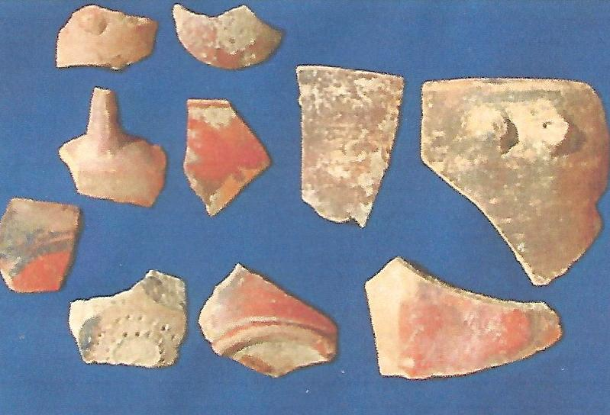

Fig 1 Pottery shards from Priniatikos Pyrgos

In the case of pottery vessels if broken, are sub-divided by sorting each group into, base shards, body and rim shards and then handles and feet (if any). For some types of finds, scientific methods are used in the process of analysis, but most specialists begin the same way. Further analysis would involve sorting by colour of the pottery and any other indications, like how the surface of the pot is finished such as burnishing and decoration, also inclusions in the clay. For example, pottery analysis from the excavation of Mochlos, East Crete revealed that local pottery inclusions consisted of fine phyllite, calcite and limestone rock fragments, whereas pottery imported from the Cyclades revealed inclusions of quartz, feldspar, sandstone and metamorphic rock fragments within a jug/jar fragment, also a painted amphora fragment having inclusions of plagioclase feldspar, quartz and biotite mica. This was found by Petrological analysis, whereby a thin slice (section) of the pot in question is mounted on a microscope slide where under the microscope the inclusions can be identified and the original source of the material confirmed.

Mochlos is an important Minoan coastal town that flourished during the Neopalatial period 16th century B.C. where a large number of houses have been discovered. On the opposite coast a craftsman compound area, the so called Artisans Quarter has been excavated. It provided evidence for large scale pottery production, including a kiln, potters wheels and a proposed potter’s pit. The typological study and petrographic analysis of the pottery assemblages established the locally made pottery, but also identified a small amount of imported vessels.

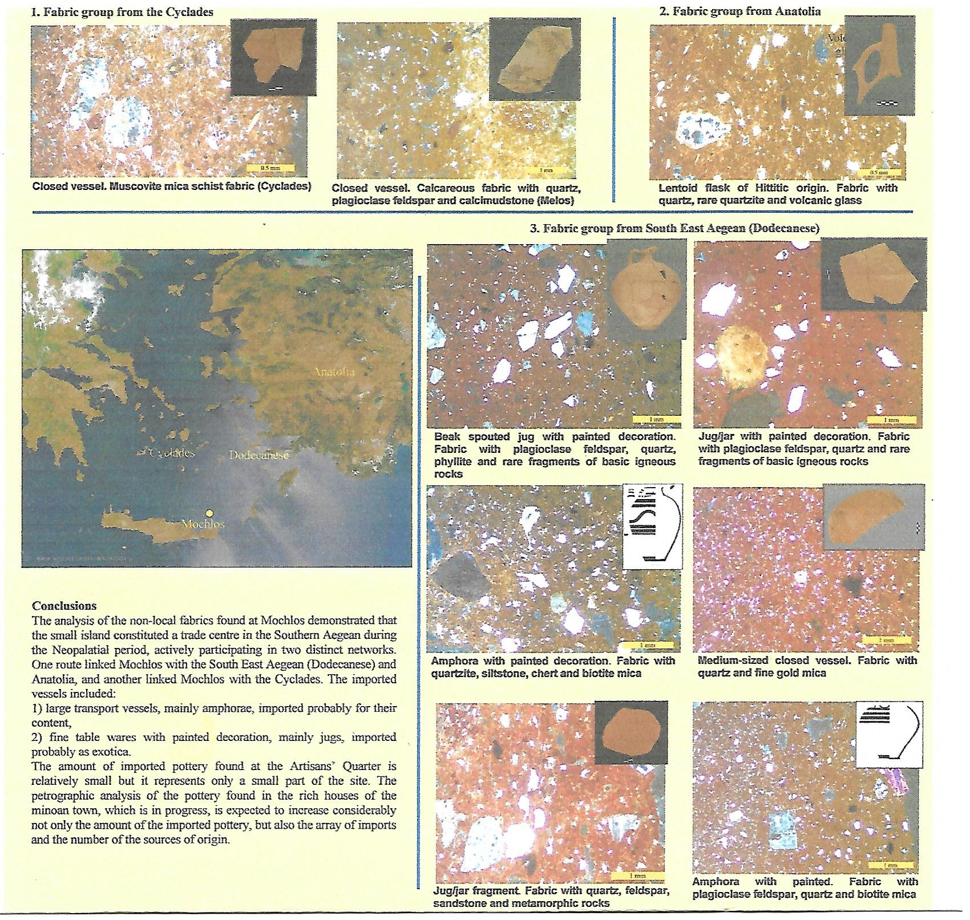

Fig 2 Pottery fabrics from Mochlos

Courtesy Eleni Nodarou, Jerolyn Morrison, Kelly Barnard

Petrographic Analysis of the Late Minoan 111 Pottery Assemblages

From Mochlos East Crete

Petrographic analysis is widely applied in the study of pre-historic ceramics, as the characterization of petrographic fabric groups provides valuable information on the provenance and technology of the ceramic material under study. In many instances petrography has proved to be the best compliment to macroscopic analysis, and, in the case of Crete it has become a routine part of ceramic studies.

The ceramic samples from Mochlos were selected from diagnostic shapes in an attempt to provide quantitative and qualitative representation of the assemblage. It was seen that the course wares were manufactured in a phyllite fabric, but there was variability in the colour and texture of the clay and in quantity and nature of the inclusions. The sampling was carried out in order to clarify whether there was any internal grouping within the course wares which may relate to the function of the vessels (i.e., storage and various cooking pots) and/or to the source of the raw material.

The main fabrics from Mochlos were first grouped and characterized, and, when possible, they were compared with fine fabrics from other sites and with published data. An attempt was then made to identify imports. The analysis resulted in the establishment of 13 petrographic groups.

When studying the petrology of ceramics, it is useful to know the geology of the area when grouping samples on the basis of their inclusions in order to get an idea of what is to be expected in locally made pottery. Although the geology of the Mochlos area has been discussed in detail elsewhere (Soles 2003, l, 7-8, l03-l04) it is worth stressing a few points regarding rocks and sediment types in the area of Mochlos that will be useful when referring to local fabrics.

The island of Mochlos was once connected to the opposite coast of Northern Crete by a new sub-merged narrow isthmus of land (Soles 2003,l) It’s geology matches that of the coast and is dominated by the presence of crystalline limestone of Permian age. The absence of sediments suitable for pottery manufacture is one reason why there is no evidence of pottery production on the island. The closest source of raw materials may have been the plain on the opposite coast. The plain and modern village of Mochlos, lie in a tectonic valley flanked on the Eastern and Western side by the Ornos mountain range. (Soles 2004, l55, Fig ll, l) that consists of crystalline limestone. The southern side is dominated by the phyllite – quartzite series of Permian – Triassic age. This series appears in outcrops across North Eastern Crete and is characterized by dark gray, greenish or maroon phillites with intercalations of sandstone, quartzite, limestone and dolomite. (Papastamatiou 1959). The plain comprises a multitude of materials, mainly, Pleistocene fluvial deposits containing gravels, pebbles, and red sands, along with Miocene marine formations ( marls and sandstones).

The products of erosion of the plain of Mochlos as well as the marl deposits that exist in the vicinity would have provided all the necessary raw materials for pottery manufacture.

The Beginning of Pottery Production

Neolithic Period.

The first known pottery makers began in the Neolithic period at Knossos Crete, where a date of 6000 plus or minus 180 B.C. (J.D. Evans 1964) was confirmed.

Most Neolithic Cretan houses were made of mud brick or more perishable materials, set on stone foundations so as to raise the walls above the dampness of the ground. Families lived in villages close together. Caves were sometimes used as homes and were symbolic to the religion. These people would make offerings of pottery which contained other goods placed within them. Agriculture was the main-stay of the economy and pottery would have been an important household item. Most Neolithic Cretan vessels were utilitarian and serviceable, the best pieces being carefully decorated, although not quite so artistic as some contemporary work from the Greek mainland.

The earliest Cretan potters produced course dark ware with thick, heavily burnished walls. These Neolithic pots are made from natural occurring materials, the main ingredient being clay, which is a fine-grained mixture hydrated alumino silicates and other minerals like rock particles and organic materials. All Neolithic pottery is made by hand and fired to a low temperature. The texture is normally course and often additional gritty fragments are mixed with the raw clays to make them even courser – gritty clay shrinks less when drying and will not crack so easily.

There are a variety of shapes in the early to middle Neolithic pottery which helps to identify the evolutionary phases. The most common shapes are, open mouth bowls, some smaller than others but large enough for storage. Others include narrow mouthed jars, small - mouthed bowls, and pedestal bowls. Handles vary from a design which looks like a wishbone to a more simple style. Patterns consist of short horizontal lines, stripes and triangles, as well as horizontal bands.

Vase shapes from the Cretan Late Neolithic are more varied than before, with both shallow and deep bowls, cups and jars of several types. Most Neolithic Cretan vessels are black in colour.

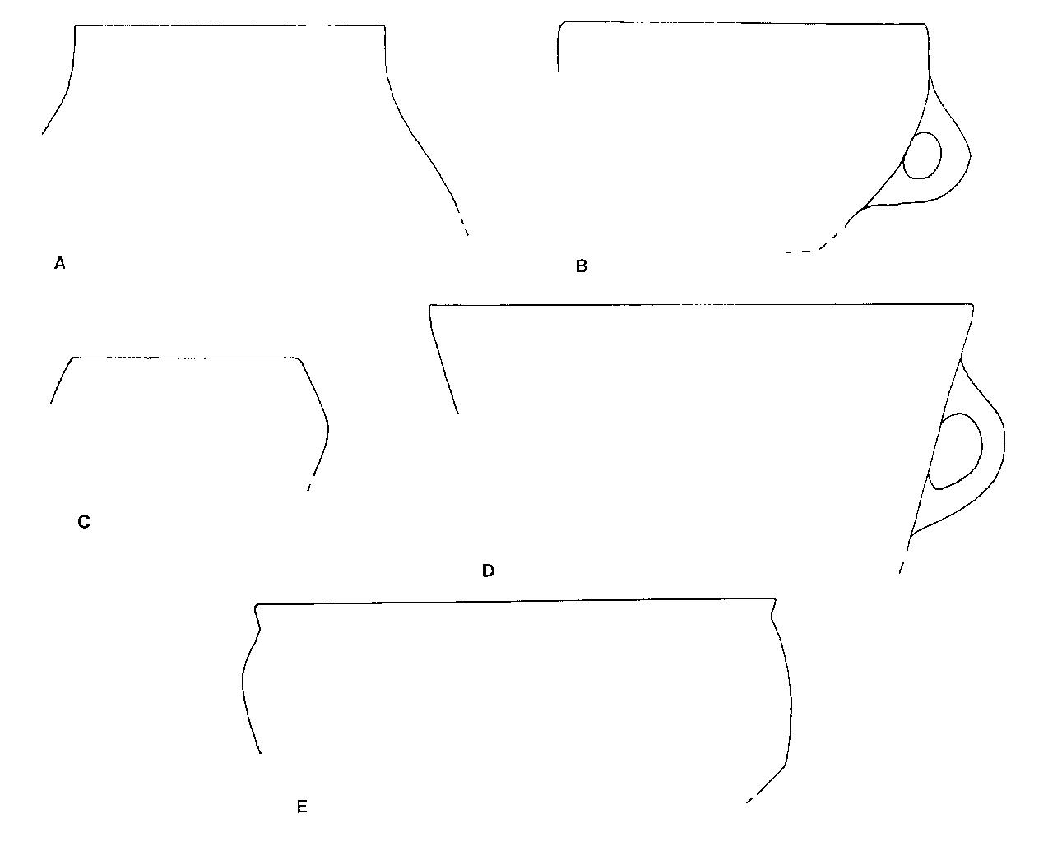

Fig 3 Early Neolithic ll pottery shapes from Knossos.

After Betancourt

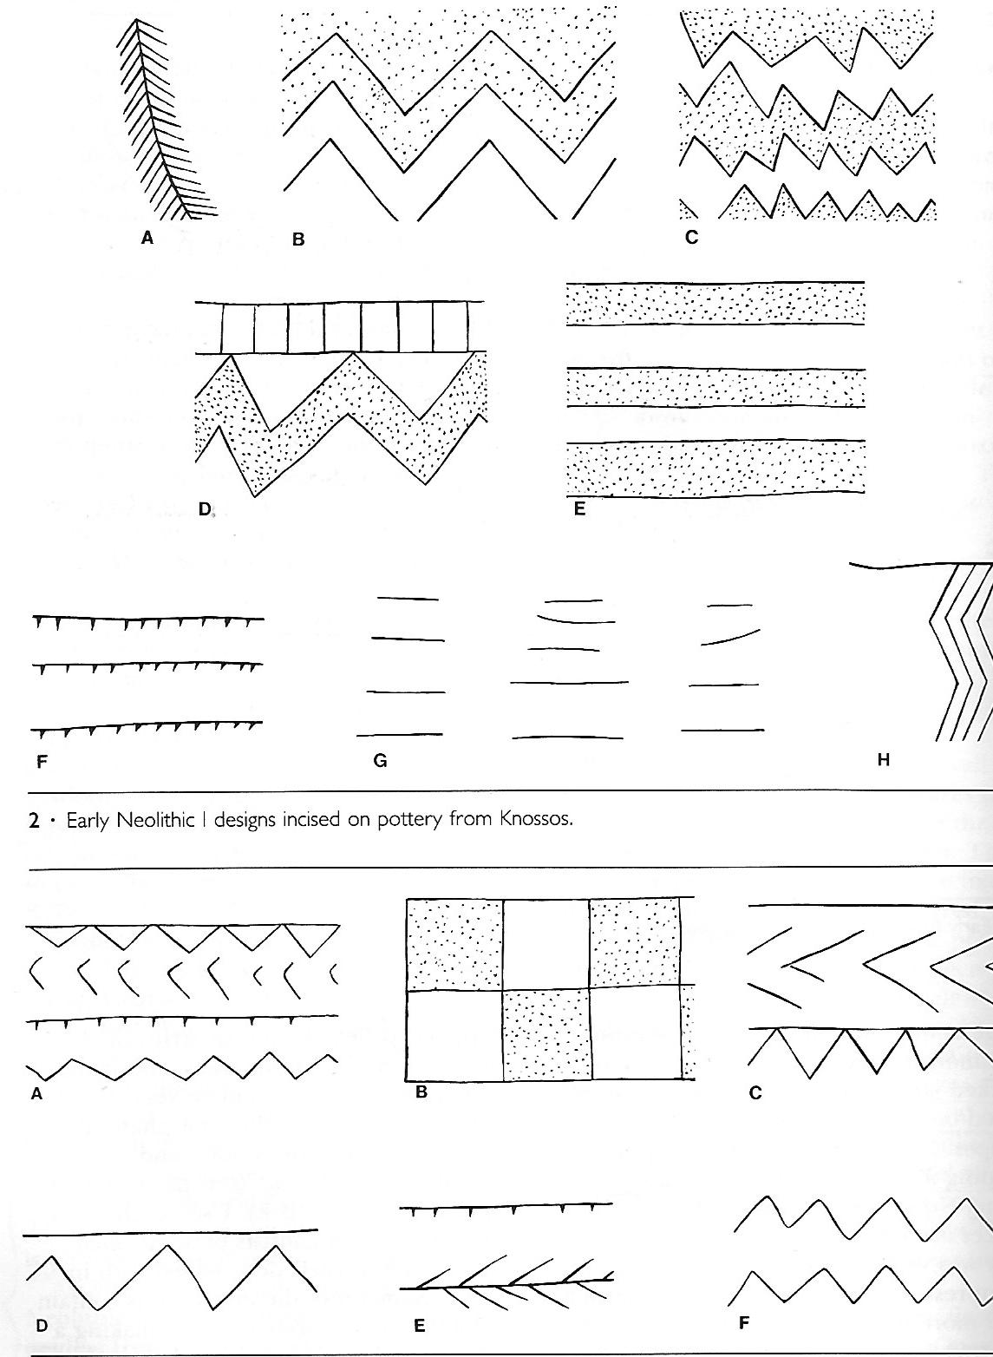

Fig 4 Early Neolithic incised pottery designs Knossos

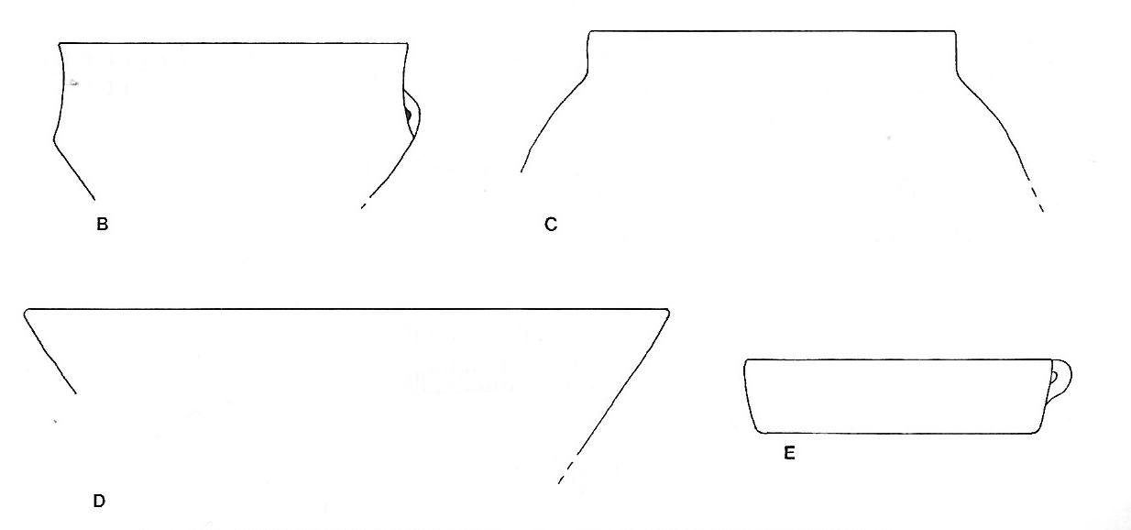

Fig 5 Middle Neolithic shapes from Knossos

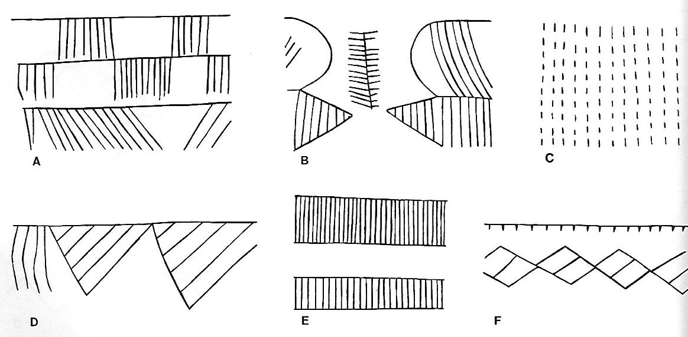

Fig 6 Middle Neolithic incised designs from Knossos.

After Betancourt

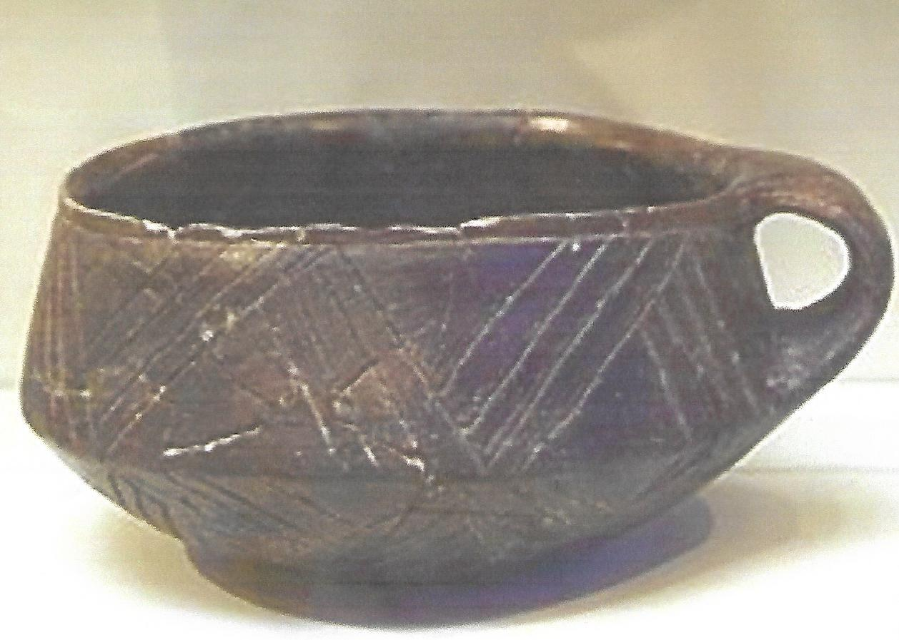

Fig 7

Neolithic pot c 4500 – 3000 BC with incised decoration from Knossos

Bronze Age

Bronze Age production of ceramics extends from the small domestic existence to mass – production in workshops, with parallel developments in technique. Outside influences mainly from the Cyclades, Asia Minor and the north-east Aegean, detectable in the final Neolithic period, now become more deviant. This influence in combination with the rise in the number of settlements in the Early Minoan period, leads us to think that Crete was partially settled on the threshold of the Bronze Age

Minoan Chronology Table

3500 2900 BC EM1 Pre-palatial

2900 - 2300 BC EM11

2300 - 2100 BC EM111

2100 - 1900 BC MM1A

1900 - 1800 BC MM1B Proto Palatial

1800 - 1750 BC MM11A (Old Palace Period)

1750 - 1700 BC MM11B Neo Palatial

1700 - 1650 BC MM111A (New Palace Period)

1650 - 1600 BC MM111B

1600 - 1500 BC LM1A

1500 - 1450 BC LM1B Post Palatial

1450 – 1400 BC LM11 Post Palatial (at Knossos

1400 – 1350 BC LM111A Final Palace Period)

1350 – 1100 BC LM111B

Fig 8

Early Minoan Period

At first the early Minoan vases were hand - made like the Neolithic vases but better fired. During Minoan11 settlements were expanding, new sites founded and trade flourished. Technology improves in a whole new range of products and Cretan pottery extends in progress. Early Minoan wares are especially well made, the best pieces being firm and durable, with excellent potting and surface decoration outstanding. The Early Minoan styles have many common features, which became popular during the Bronze Age and were exported to different parts of Crete.

During the Early Minoan1 phase, round bottomed jugs with beaked spouts appear as well as, bowls on high pedestals and decorated with simple linear patterns, in a red or brown semi-lustrous paint on a yellowish back ground.

Other vessels such as suspension pots are decorated with simple drawn incised patterns or with simple dots over the surface of the vase.

The best achievement of the pottery from the Early Minoan ll phase is undoubtedly the stunning Vasiliki ware. The jugs of this period are flat bottomed and decoration is dark or dull red or brown on a light background. Among the patterns are hatched triangles, concentric semicircles, the butterfly pattern or latticework.

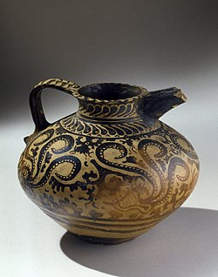

Fig 9 Early Minoan11 Jug, dark on light decoration.

The next phase we see the reverse system of decoration, light on dark and patterns mostly curvilinear and include running spirals and interlocking curves. Other patterns include crosshatched circles, lozenges and zigzags often linked together. Animal figures are evident at this time and polychrome is introduced before the end of the period and there is a great variety of shapes. Spouts are now shorter, handles are round, or almost round in section and bases appear flatter. The most common shape is a rounded teacup often without a handle.

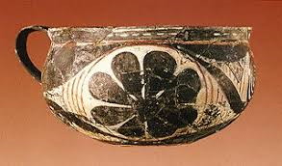

Fig 10 Middle Minoan Kamares Ware round cup

During the Middle Minoan period both dark -on- light and light - on – dark decoration is evident. A typical vessel of this period is a small jug with a short cut- away -neck, also a handless cup, often with a pedestal, which later shows a ribbon handle and slightly out – curving sides.

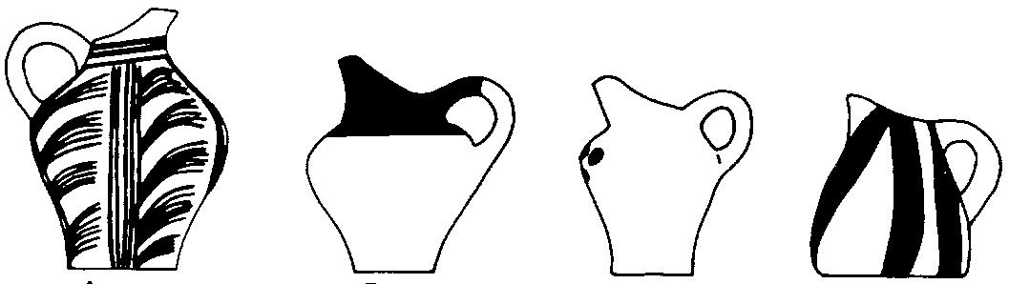

Fig 11 Middle Minoan 1- 11 dark on light jugs

The introduction of the potter’s wheel which succeeded the earlier turn – table led to a much better and faster way for pottery production. The earliest clay vases made with the wheel are from the Minoan1B phase.

During the Early Palace period, which began a little earlier than the end of Middle Minoan1A, the most stunning Cretan pottery appears, the well known Kamares Ware.

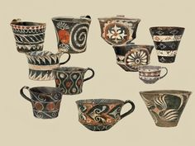

Fig 12 Early Minoan Kamares Ware Cups

The pottery of the early stages of the second phase ( Middle Minoan 11C 1700 – 1550 B.C ) uses much the same forms of decoration as the previous period. Flowers, leaves and often spirals and rosettes are painted in white on a black background.

The Late Minoan11 period ( l550 – 1400 B.C.) the so – called “Palace Style” at Knossos, the style of decoration was originally confined to the Knossos area, but during the earliest phase of the next period it spread throughout the island. The pottery is fired at a higher temperature and the designs are made using a lustrous paint, ranging from black to brown and red with white colour for other details on zones or panels. Decoration consists of arcs and dots and horizontal stripes.

Fig 13 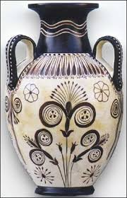

Palace Style Amphora

Knossos Palace

Knossos Palace in Crete, Greece covers an area of around 700,000 metres. It is one of the most important administration centres of the Mycenaean period.

In 1990, while excavating Knossos palace, archaeologist Sir Arthur Evans discovered many of the Linear B clay tablets which reveal inventories of many important items. For instance, a variety of pottery vessels are recorded, such as jars, vases, cups, bowls, cooking pots, cooking trays, amphorae and pithoi are among other vessels produced, even a special pot for libation.

Of special; importance were the huge pithoi used to store oil and oil based products such as perfumes, grain wine and other commodities. The Linear B tablets tell us that produce from surrounding farmland was collected, recorded and stored in the palaces, as seen from the large storage – rooms at Knossos where huge pithoi, amphorae and other such storage vessels were kept and where the palaces appear to have exorcized an extent of control of the trade. Some of the storage pots were used at the palace and others for transport not only within the local areas but overseas contact.

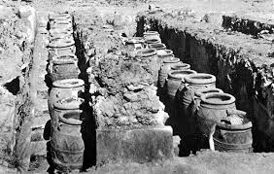

Fig 14 The storage rooms at Knossos

These gigantic Pithoi (storage jars) have been manufactured in Crete since Minoan times and are still made in some villages today. They often stand well over the height of a man. In the palace at Knossos there was room for some 400 of these vessels, placed in a row inside the narrow magazines.

A study carried out by John Younger in 2003 used a computer program “Vase” to calculate the maximum capacity of a Late Minoan pithos, catalogue number ZA ZB3. The program required the drawing of a profile on the computer screen and the entry of a parameter – Younger used height which in this case was l.7m (5.6 ft) “vase” computed 996 litre which is slightly too great, because it was based on external dimensions. At the density of pure water, l kg per litre, the contents of a full pithos would weigh about a ton. Moreover the pithos selected was not among the largest. On similar studies of some other pithoi mentioned by Ventris and Chadwick, he obtained volumes such as 1430.5 litres, 1377.5 litres, 1334 litres and so on, with full weights in excess of two tons. Dry goods would be much less dense, but even half the density, a weight of about a ton, is far beyond any handling operations by individuals, or team of individuals who could not obtain a purchase in sufficient numbers in the space around the jar to effect even a simple lift.

If the large pithoi were sunk into the floor in storage rooms, as the archaeological evidence indicates they were, their weight and bulk raises a question of how they were brought there. Handling a full pithos except by extensive apparatus of tracks and cranes, of which there is no evidence, is unlikely. It is thought that maybe they were brought in empty, set in place, and then filled from smaller pithoi or some other small vessel. The pithoi the Uluburun Ship was carrying, if full of liquid would have been too heavy for manual handling. Including the considerable weights of the containers, the total weights can be estimated at around 150 to 420kg. Equipment for hauling to the ship and lowering into the hold must have been used.

Early pithoi were usually decorated with the simple “trickle pattern” favoured over a long period. The decoration was applied at the top of the pot and continued down the buff colour clay. Many handles were applied in sets of two around the shoulders and one above the base. The lids were either flat clay or stone, or with some sort of fabric tied around the neck of the vessel.

Minoan pithoi were usually decorated with patterns by adding round clay “medallions, an early pattern, knobs and bands of applied thumb-impressed decoration, broad flat wavy bands and the “rope pattern”, a moulded imitation of the actual ropes with which they were bound for purposes of transport and reinforcement.

From the late Minoan11 period onwards this rope-pattern fell out of favour and replaced by raised incised bands running around the body. Decorated handles were occasionally added. Some late Bronze Age pithoi are almost barrel-shaped. The manufacture of the pithoi continues into the Iron Age and some examples of the Orientalizing period were adorned with figures or various ornaments in relief. These pithoi, often counting among the best artistic creations of the time, were characterized by stamped Oriental motifs, such as sphinxes and lions, sometimes horses.

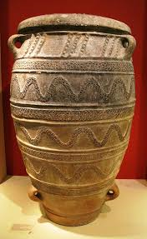

Fig 15 Pithos decorated with relief wavy lines

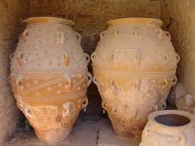

Fig 16 Giant size Pithoi stored at Knossos

Pithoi used for burial

There are three sites where pithos burials have been found dated within EM lll: Archanes - Phourni and Pacheia Ammos. One pithos was found in Tholos Gamma and another one in the north-central part of the Area of the Rocks at Archanes – Phourni. A pithos burial has also been found at Sissi in Crete dated to MM11.

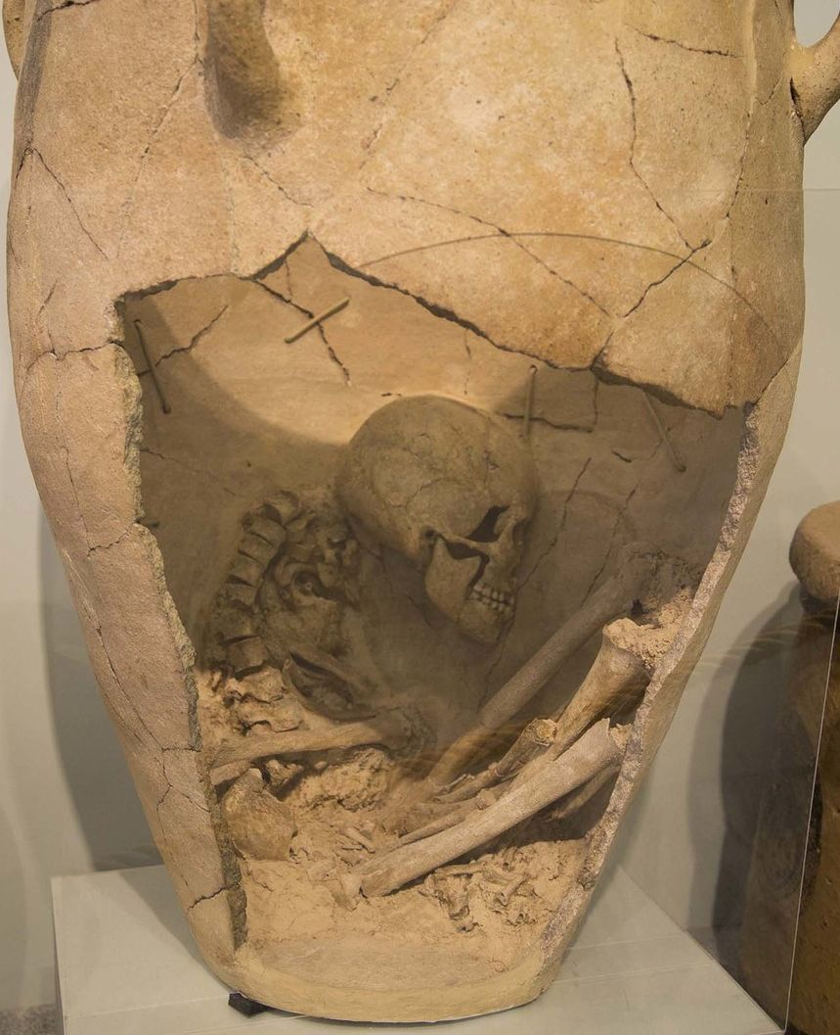

Fig 17 Giant Pithos used for a burial EM111

This form of burial appears at the very end of the Early Minoan period, at the same sites where Larnax burial is more or less contemporarily introduced and becomes more popular in the Middle Minoan period. Pithos burial is common in Anatolia in the early Bronze Age and also occurs in the Final Neolithic cemetery at Kephala on Keos and in the early Helladic ll “round graves” on Lefkas. It is however, relatively rare during the Early Bronze Age on the Greek mainland and in the Cyclades, while in the Middle Bronze Age in these areas it is a form used mostly for the burial of children.

The Larnax (coffin)

While there were different burial practices found across Crete, the most common seems to have been the Larnax, a chest sized coffin, in which the remains of the dead were ultimately inhumed. Minoan larnaks were made of terracotta (baked clay), but their structure resembles a wooden chest.

The use of the larnax or clay coffin appears in the Early Minoan111 period at Pachia Ammos and Gournia in East Crete and continues occasionally throughout Minoan times, disappearing after the burial customs of cremation became prevalent.

The early larnax are either plain or with a simple linear decoration, they normally had an elliptical form and were very short: the dead were trussed tight and placed in them with feet drawn up knees to chin and the head raised, imitating an embryonic position.

In the late Minoan111 period we see the larnax painted in the style of the time, decorated with abstract patterns, birds, flowers fish and octopuses besides other motifs, such as the double axe and other sacred objects, like bulls and other animals, human figures and sometimes ships.

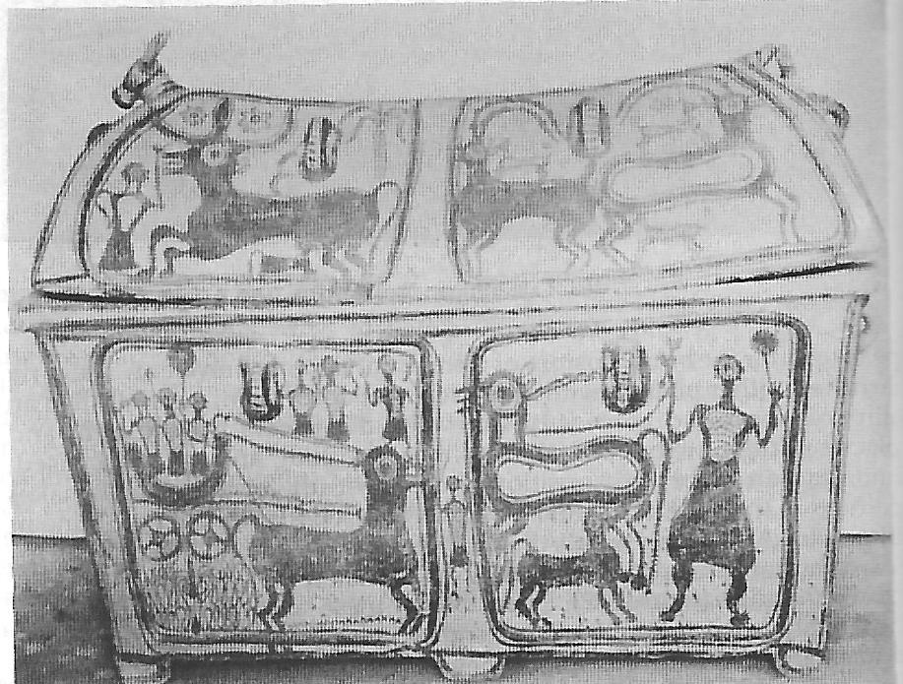

Fig 18 Minoan Larnax

Most larnax are in the form of rectangular chests with paneled sides. They have short thick legs and a gabled lid, with a ridge pole projecting at either end so they can be lifted, occasionally the lid is flat. Another popular type of larnax is the bathtub larnax, which is oval in shape, tapering toward the flat base and provided with a flat projecting rim and horizontal handles. The best known example is the larnax you see above which comes from the village of Episkopi East Crete. It has twelve paneled scenes which includes chariots and processions and is exhibited in the Archaeological Collection of Ierapetra.

Detailed comparison of both the chest and bathtub larnax decorations, show affinities to those produced at workshops in other regions, implying that maybe a potter who learned his craft at, for instance Sitia moved to the Mirabella area practicing there, either temporarily or permanently, or possibly a local craftsman trying to imitate the product of a potter at Sitia.

Amphora

The discovery of Linear A and Linear B tablets, listing commodities in the archive areas at the Palace of SSYL KO . V v = Ko no so – Knossos, suggests a highly organized bureaucracy as well as a system of record keeping that controlled incoming and outgoing products, such as the Linear B clay tablet you see below which tells us that s ] = *Te jo* has 542 SSYL A = q k l M u = a pi po ri we = amphorae containing w N o e ra wo = olive oil

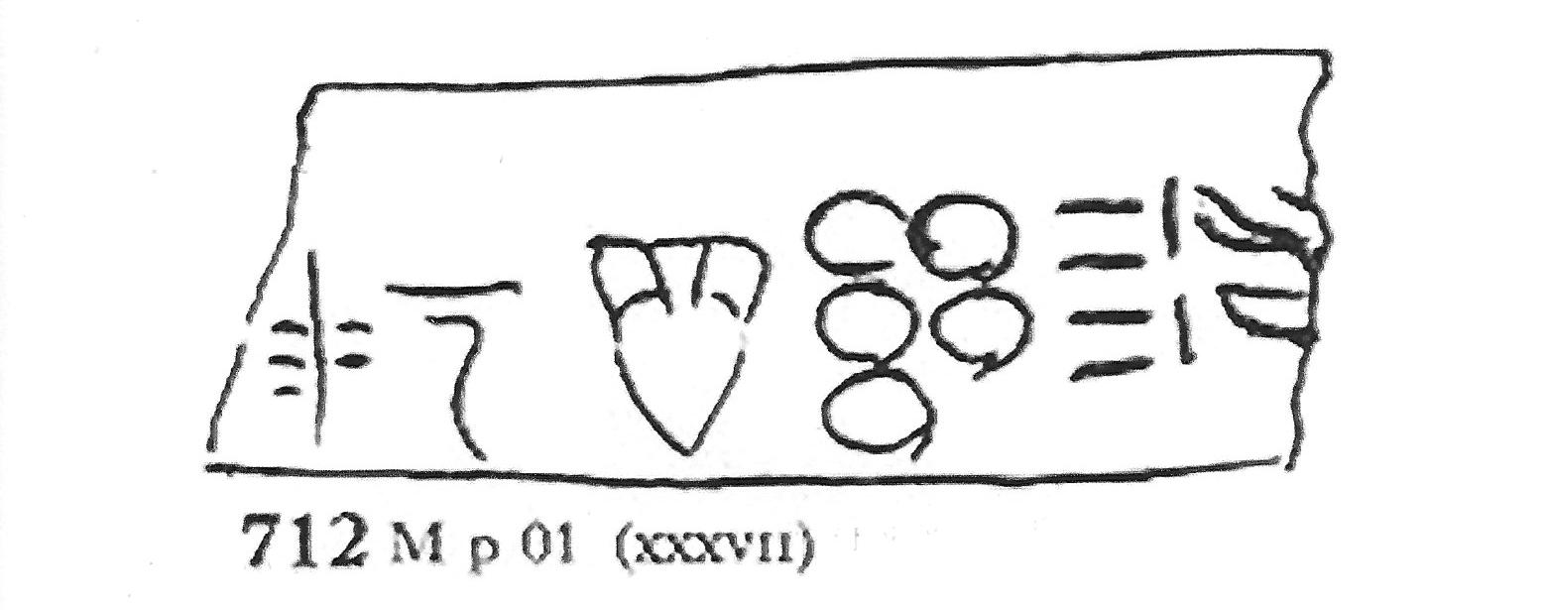

Fig 19

Another Linear B tablet below KN 713M 0l where you see the incharged Supersyllabogram A = q k l M u = amphora. It would seem possible that a F w N = do e ra = slave has the role of bringing J < = meri = “ honey” to be poured into the amphora. Perhaps ready for storage or transport.

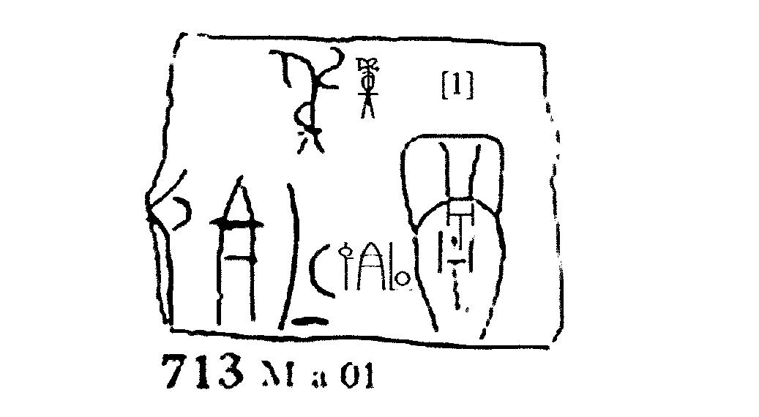

Fig 20

Please see Chart below for illustration of incharged and surcharged Supersyllabograms for the Vessels Sector in Mycenaean Linear B.

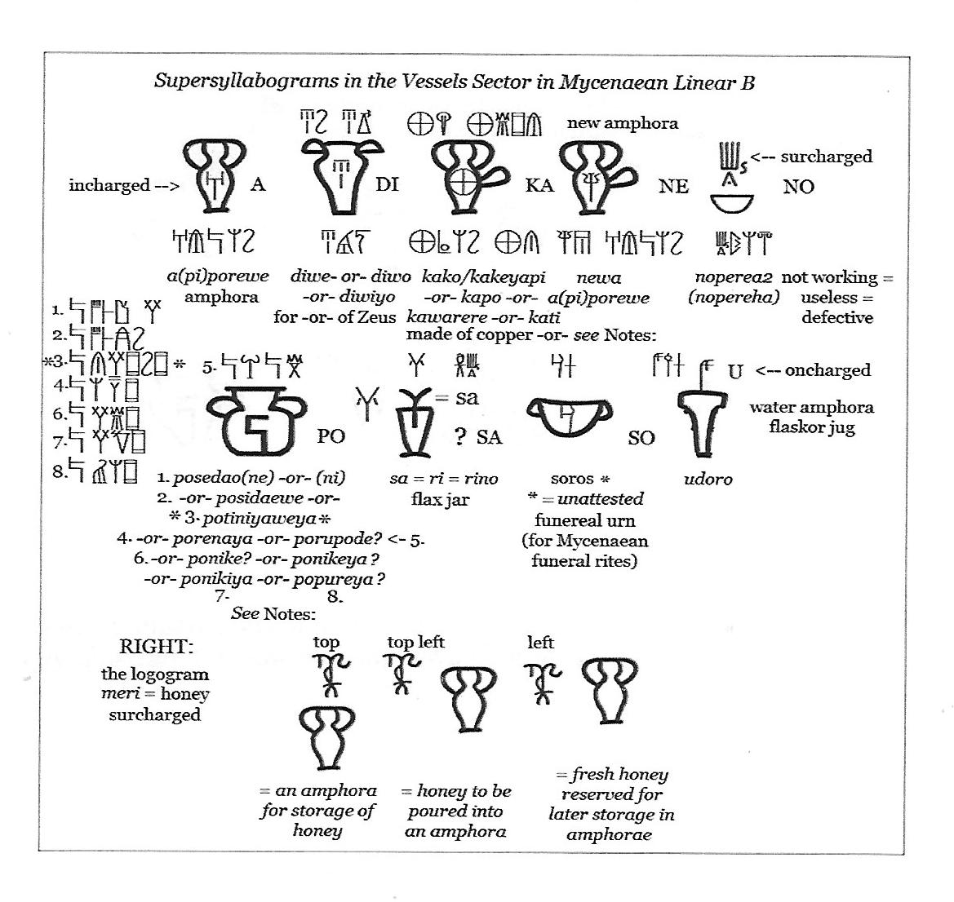

Fig 21

This chart shows the characteristic of supersyllabograms in the pottery and vessels sector of the Minoan and Mycenaean periods. The majority of them are *attributive* and *dependent* on the ideogram they qualify. Attributive supersyllabograms always appear inside the ideogram which they qualify, never adjacent to it. They always describe an *actual attribute* of the ideogram. For instance, the supersyllabogram A - inside the ideogram for vessel with 2 handles is the first syllable of the Mycenaean word q k l M u = a pi po re we = amphora, thus identifying the vessel as an amphora.

This Linear B tablet was first translated by Michael Ventris 1952

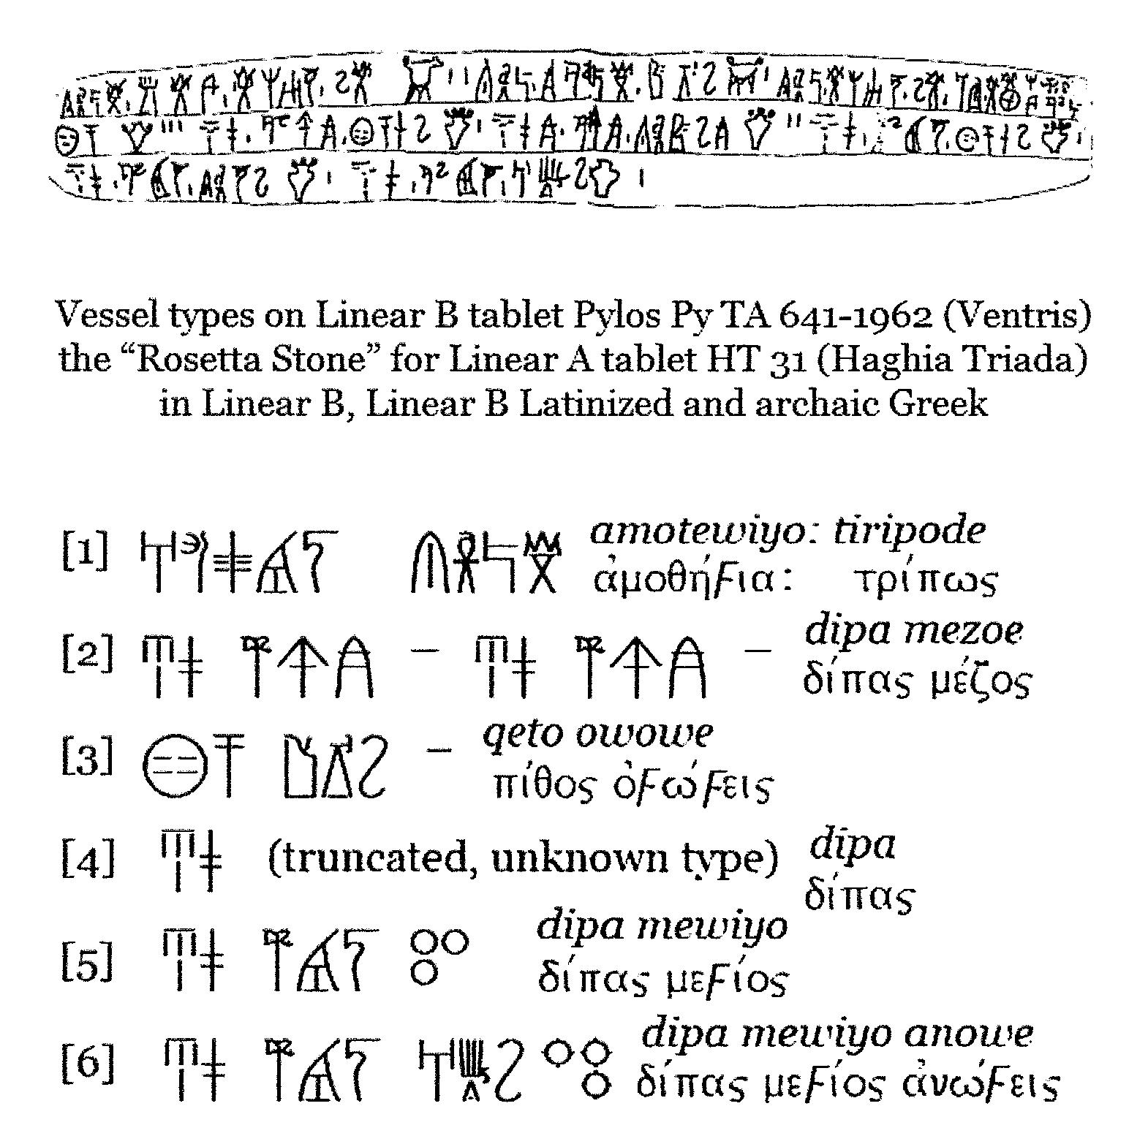

Fig 22 Courtesy Richard Vallance Janke

Translated it reads – *Aigeus* the  *ka ra me u* = “potter” is making *ti ri po d*e= tripods of the Cretan style. There are 2 tripods with three legs and two handles, l tripod with a single handle on one foot, l tripod with the legs burnt from the legs up, 3 pots with two handles, 2 big pots with three handles, l smaller pot with four handles, l small type of *di pa* = cup/goblet with three handles, l small type of *di pa* = cup/goblet without handles.

The chart below shows vessel type comparison between Linear A tablet HT 3l (Haghia Triada) and Linear B tablet Pylos 641 – 1952 (Ventris)

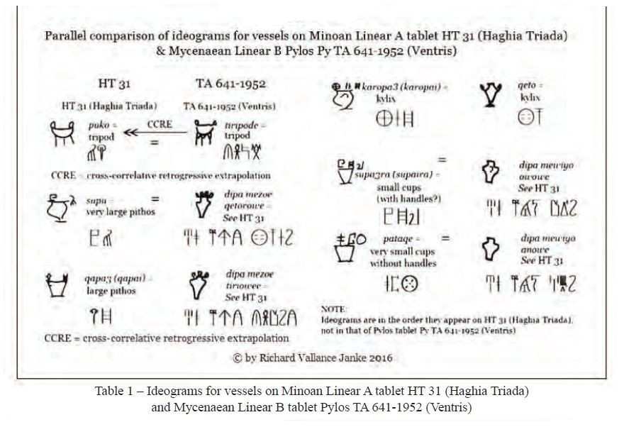

Fig 23 Courtesy Richard Vallance Janke

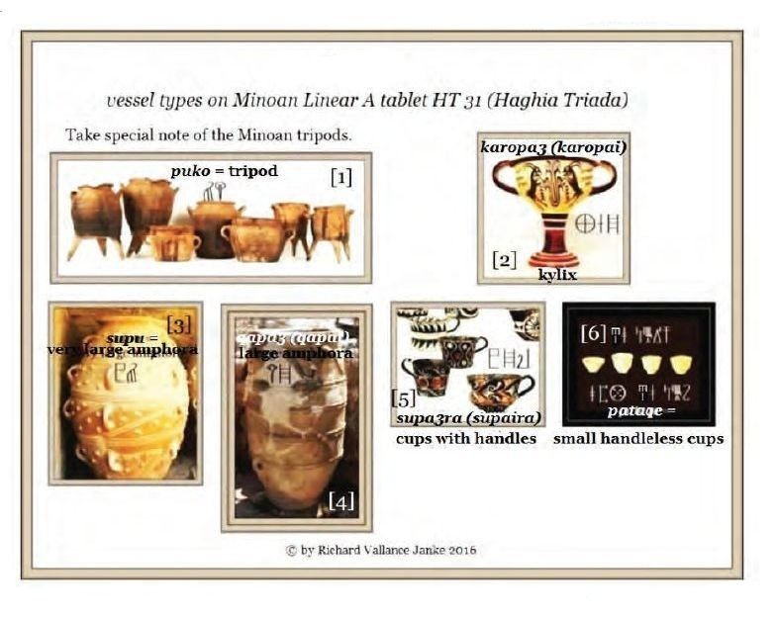

Fig 24 Courtesy Richard Vallance Janke

Stirrup jars Inscribed and Stirrup Jars for Transport

Some inscribed stirrup jars are thought to be guest – gifts which served to openly advertise the person who gave the vase and its content, suggesting that inscribed vases are personal reminders of actual guest friends and travels undertaken.

The majority of Minoan exports were their pottery, found across the Aegean, Levant and the Nile Delta, including as far as, the Lupani islands between Italy and Sicily. Minoan pottery was also popular in Egypt after the reign of Tuthmosis ll ( l492 – l479 BC ) after which most Aegean pottery and its contents exported to Egypt was Mycenaean.

Fig 25 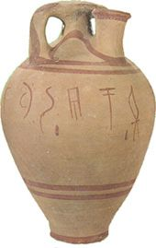

Inscribed Stirrup jar from Thebes

Inscribed *ka ra re we* = “stirrup jars” have been found on many sites inclusive of Mycenae, Tiryns, Orchomenos, Eluesis and Thebes. The longer inscriptions consist of three words, as on the inscribed jar found at Eluesis, two of which are personal names and one of which is a place name. Sometimes the adjective *wa na ka te ro*, that is the adjective of the word *W*anax, king, i.e. “royal”, is substituted for one personal name, here shortened to *WA* . The place names probably are of the place of manufacture of the jars and/or of the contents.

Stirrup jars for Transport

Looking at the extent of Linear B inscribed transport stirrup jars, the majority were manufactured in west Crete, a few in central Crete/ including the well known inscribed piece from the unexplored Mansion at Knossos, and probably none on the mainland. At Thebes we have by far the largest and most representative deposit of inscribed stirrup jars.

We know that west Crete was not the only area producing stirrup jars for export, including inscribed pieces. Surprisingly, with Knossos located on the *north* coast of central Crete, south central Crete produced many of the central Cretan transport jars intended for export. This south central fabric is seen even at Knossos, indicating that Knossos was more a consumer of transport stirrup jars than an exporter.

Samples from two inscribed stirrup jars found at Malia excavations in 1990, together with six examples of un-inscribed jars from the same context, were petrographically analyzed. The jars compositions were compared with those of similar stirrup jars found at several sites in Crete, principally, Knossos, Chania, Kommos and Palaikastro.

Please consult, Petrographic and Chemical Analysis of the Inscribed and other Stirrup Jars from Malia. by Richard Jones and Peter Day 1991, for the full report.

Mycenaean Pottery.

Early Mycenaean pottery Late Helladic 1 and 2, 16th – 15th century B.C. combines the earlier Middle Helladic tradition with the pottery styles of Minoan Crete. The pottery from this period is of the highest quality and known for its light colour clay, glossy brown-black paint and its strong influence on the pottery styles of mainland Greece.

Minyan Ware pottery associated with the Middle Helladic period (c2000/1900 – 1500BC), initially discovered by Heinrich Schliemann on his excavation in Orchomenos Greece, during the 1960,s confirmed that Minyan ware evolved from the burnished pottery developed by the Tiryns culture of the Early Helladic111 period (c2200/2150 – 200/1900 BC). Minyan ware is a form of monochrome burnished pottery produced from extremely fine or moderately fine clay. Varieties of Minyan Ware entail Yellow, Red, Gray and Black ( Argive). Open forms such as goblets and kantharoi are the most common shapes in all types of Minyan Ware.

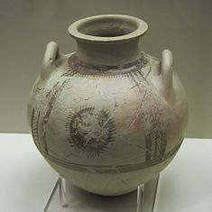

Fig 26 Middle Helladic111 Minyan Ware Amphora

Minyan Ware from the Middle Helladic1 period is decorated in the form of grooves on the upper shoulder of kantharoi and bowls. During the Middle Helladic11 period stamped concentric circles and “festoons” (or parallel semicircles) became a common characteristic of decoration, especially on Black (or argive) Minyan Ware.

Gray Minyan Ware is mostly found in central Greece and is also common in the Peloponnese, black or Argive is common in northern Peloponnese, red commonly found in Aegina, Attica, the northern Cyclades and Boeotia. Yellow Minyan Ware first appears during the Middle Helladic11 periods. Due to its light surface colour, this particular variety of pottery is decorated with dark matt-paint.

The Late Helladic1 pottery comprises mainly of small vases, while larger vases are still manufactured in the Middle Helladic tradition. The large Palace style amphorae with its plant and marine decorative motifs, was an impressive Mycenaean creation which over time spread to Crete, where two large fragments of a Grey Minyan Ware rounded bowl was found at Knossos (Hood 1971,) The bowl with everted rim had been found on the south side of the Royal Road, located at the north west corner of the Palace. (Hood – Smyth 1981, 51 Nr, 214 – 215. The bowl was handmade, with slightly sandy and greyish – brown fabric; the exterior surface and the inner rim are burnished with a half preserved vertical strap handle. The vessel is thought to have been produced in central Greece, perhaps at Orthomenos

During the l4th and l3th centuries B.C.(Late Helladic111A & B ) pottery is characterized by the consistent high quality of the clay and general uniformity of decoration throughout the Argolid, Attica and other regions of the Mycenaean world. Stylized plant, animal and simple linear motifs organized into groups, decorate stirrup – jars, jugs, kraters and kylikes which are the most common shapes. Mycenaean pottery spread throughout the Mediterranean as far as Syria, Egypt and Spain. Pictorial style pottery consisted mainly of kraters with human, chariot, horse and bull representations and produced at Berbati in the Argolid. It was exported to Cyprus where it was widely imitated.

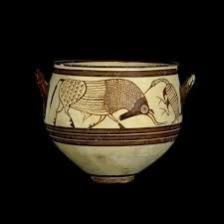

Fig 27 Late Helladic111 Deep bowl

Popular Vessel Shapes and Decoration

Plain bold horizontal lines and whorls continued to be popular for decoration, usually well chosen to compliment the shape of the vessel. Vessel forms also evolve, such as the stemmed cups, the stems becoming longer and the bowls more shallow over time. New types of vessels were produced like the one-handled teacups, tankards and jugs with vertical strap handles and either spouts or cut – away necks.

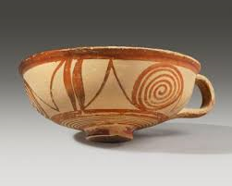

Fig 28 Late Helladic Semi-globular cup 1600-1200 BC

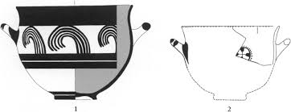

Late Helladic decorated Deep Bowl

After Betancourt

Fig 29

In the 12th century BC (Late Helladic111C), after the destruction of the palatial centres artistic uniformity was disrupted and a number of local workshops with their own traits evolved. Granary Style pottery, specimens of which were found in an underground storeroom near the Lion Gate in the citadel at Mycenae, has simple linear decoration.

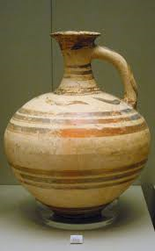

Fig 30 Late Helladic Granary Style Jug

Argive workshops produced the so-called Close Style, characterized by numerous tiny abstract motifs. The Pictorial Style continued to evolve, while the octopus style, with representations of octopuses, fish, birds and complementary motifs was popular in the Dodecanese, the Cyclades and Crete. Towards the end of the Mycenaean period, the transitional sub-Mycenaean pottery of the llth century BC comprised largely small vessels with simple linear decoration which were the precursors of Greek Geometric styles.

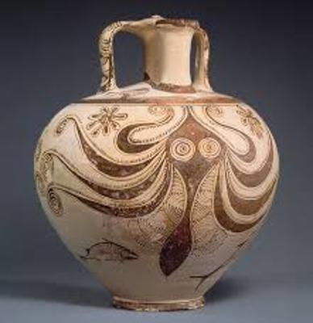

Fig 31 Stirrup Jar with octopus decoration

The above vessel type takes its name from the stirrup shaped-handles at the top of the configuration of the spout. In antiquity such jars – easy to carry and designed not to spill were mostly used to transport wine and olive oil throughout the Mediterranean. They were made in a wide range of sizes, perhaps smaller ones held perfumed oils for its owner.

Control of the sea was essential to the Mycenaean, for gaining and maintaining power over their vast domain. They did not have central consolidated power, but relied immensely on their military strength and their ability to control and defend the sea that surrounds them.

The shape of this stirrup jar and its octopus motif testifies to the importance of the sea as an avenue of communication and source of food and wealth. It is also possible that this jar was designed for the exportation of the oil from the region, to surrounding cultures. It is a celebration of Mycenae and their maritime prowess of enjoyment of the sea and the life it gives.

Pots for perfumes

It seems that the ancients paid particular attention to cleanliness. We know they used aromatic oils and ointments in bathing, like the Egyptians and later the Greeks. It is possible that almond and bitter almond as well as cedar and various native herbs, were most likely among the materials employed for the manufacture of perfumes, ointments and aromatic oils, which were stored and exported overseas in the characteristic stirrup jars.

Other more exotic ingredients, such as frankincense and myrrh would be delivered into the palaces from overseas and dispensed to workmen in small amounts. Perfumers would most likely receive the products from the palace.

The existence of a perfume laboratory has been suggested for one of the workshops at the south wing of the palace at Zakros. The Linear B scripts mention among other occupations of the population of Knossos, that of the unguent boiler.

Fig 32 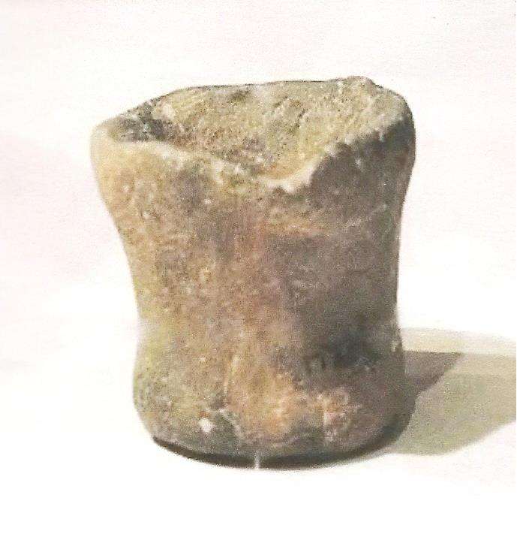

Small cup for measuring perfume Middle Minoan1A found at the Chamalevri, Bolanis workshop.

For more information, *see* Sabine Beckman. A – RE – PA on Academia.edu

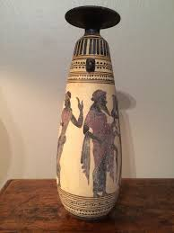

Fig 33 Alabastron used for perfume

The squat alabastron = jar, used for storing creams and unguents,first appeared in Minoan Crete and was popular in the Mycenaean period. Early examples were made from alabaster, hence the name.

Pottery Forms

As we have seen, pottery of the Minoan and Mycenaean periods cover a wide range of styles and decoration, of which both are inventive and exquisite and some carry a meaning within the decoration itself, such as this jar with the star – like pattern, indicating the study of the stars. We have further evidence from depictions of sailing boats on seals, rings and frescoes from the Middle Bronze Age (ca, 1600 – 1400 BC). We know that the Minoans were widely navigating the Mediterranean. It also seems that they studied the stars and the sunrise for navigational purposes, while transporting pottery containing goods such as, olive oil and other commodities to other countries.

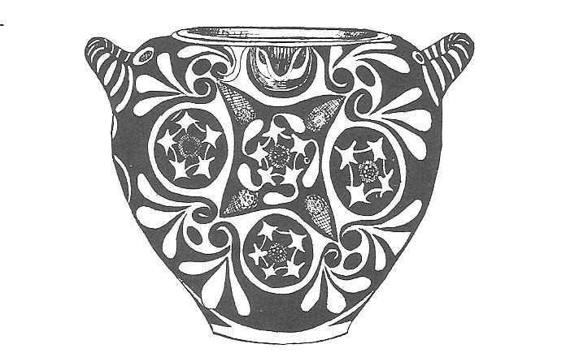

Jar with star-like decoration MM11 B

Fig 34

STYLES OF AMPHORA

The amphora is referred to by the Greek name *amphiphoreus* or *amphoreus* on clay tablets of the Mycenaean period, spelled out in the characters of the Linear B Syllabary and symbolized by the Supersyllabogram A = *a*  *pi*  *po re we* = amphora.

Shipping amphora’s which are “pointed,” that is, too narrow at the bottom to stand alone, were made in parts of the Greek world as early as the 7th century BC. The idea of streamlining the jar for transport may have been copied by the Greeks from contact with the Phoenicians, who had continued to make an adaption of the Canaanite jar; or they may have taken the idea from what they saw in Egypt, where there were colonies of Greek merchants as early as the late 7th century BC.

Like modern containers, these appear to be of a special shape and the colour also helps to distinguish them, though this varies somewhat with the firing of the individual pot. Some are labeled also by stamp impressions made before firing, set usually on top of the handles. The creamy surface with acute-angled handles, identify amphorae from Rhodes and they are marked by pairs of stamps which often contain “the rose”. Amphorae from Sinope (Turkey) on the black sea and the earliest from the island of Thasos are similarly marked. On the jars from Rhodes the month is also given. Why amphora’s were dated is not fully understood, but the chief purpose may have been to fix more closely the responsibility for them being containers of standard capacity, while one effect must have been to date the contents, identifying for instance, the age of the contents and the age of a special vintage of the finer kinds of wine, also the freshness of the cheaper which would not have been worth drinking after a year. Traders and tax collectors had to recognize the manufacture of a jar to know what capacity (within tolerances) was guaranteed, because standard containers were of different capacities in different regions.

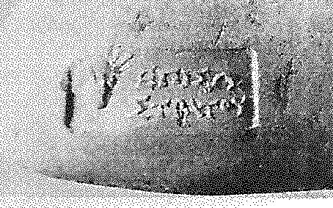 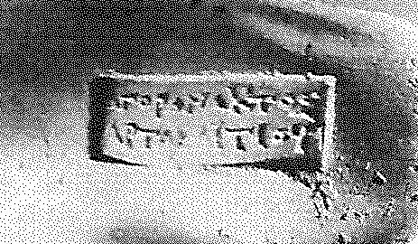

Fig 35 Amphora stamps from Rhodes

Versions of the amphora were one of many shapes used in Ancient Greek vase painting and these pots compliment the large storage container, the pithos, which makes available capacities between one-half and two and one-half tons. In contrast the amphora holds under a half ton, i.e. less than 50kg. The bodies of the two types have similar shapes. Where we see that the pithos may have a multitude of small loops or lugs for fastening a rope harness, the amphora has two expansive handles which joins the shoulder of the body and a long neck, the necks of pithoi are wide for scooping or bucket access, whereas the necks of amphorae are narrow for pouring.

Amphorae were used in vast numbers for transport and storage of various products both liquid and dry, but mostly for wine. Stoppers of perishable materials, which have rarely survived, were used to seal the contents.

The principal types of amphora existed were the *neck* amphora, in which the neck and body meet at a sharp angle; and the *one-piece* amphora, in which the neck and body form a continuous curve. The neck amphorae were commonly used in the early history of Ancient Greece, but were gradually replaced by the one-piece type from the 7th century BC onwards.

Most were produced with a pointed base to allow upright storage by embedding in soft ground, such as sand. The base facilitated transport by ship, where the amphorae were packed upright or on their sides in as many as five staggered layers. If upright, the base were most likely held by some kind of rack and ropes passed through their handles to prevent movement or toppling during rough seas. Heather and reeds may have been used as packing around the vases.

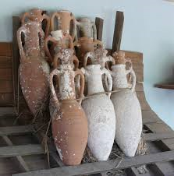

Fig 36 Amphorae stacked ready for transport.

Amphorae are of great use to Marine Archaeologists as they often indicate the age of a shipwreck, such as the Uluburun shipwreck which was carrying many of these amphorae, besides various other items.

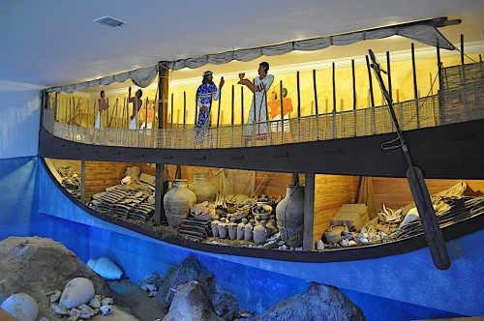

Fig 37 The Uluburun Shipwreck

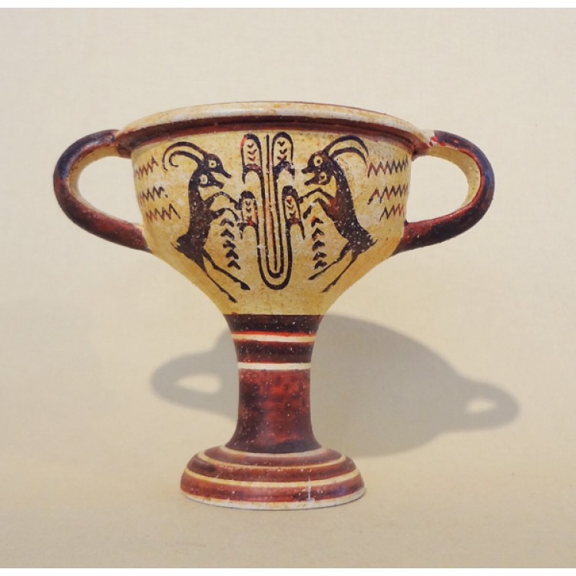

Fig38 Minoan Stem Kylix with Ibex decoration 1415-1340

Courtesy of the Archaeological Museum Heraklion

The Kylix is the most common type of wine drinking cup. It has a broad shallow body raised on a stem from the foot and usually two horizontal handles. The almost flat interior circle of the base of the cup was usually the primary surface for painting the decoration, in the black - figure and the red – figure pottery styles of the 6th and 5th century BC. The outside was also often painted. As the pictorial scenes would have been covered with wine, the scenes would only be revealed in stages, as the wine was drained from the cup.

Once the Kylix was formed, an artisan would draw a scene from Greek mythology or everyday life with a diluted glaze on the outer surface of the formation. Inside the drinking cup it-self was often a portrait of dancing or festive drinking or even warriors.

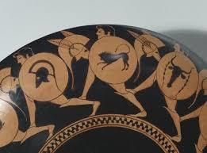

Fig 39 Ancient Greek Kylix painted with running warriors.

Cooking, serving, and drinking vessels such as the Kylix are documented on Linear B tablets, seals and vase paintings in the palaces of Pylos, Mycenae, Thebes and Knossos.

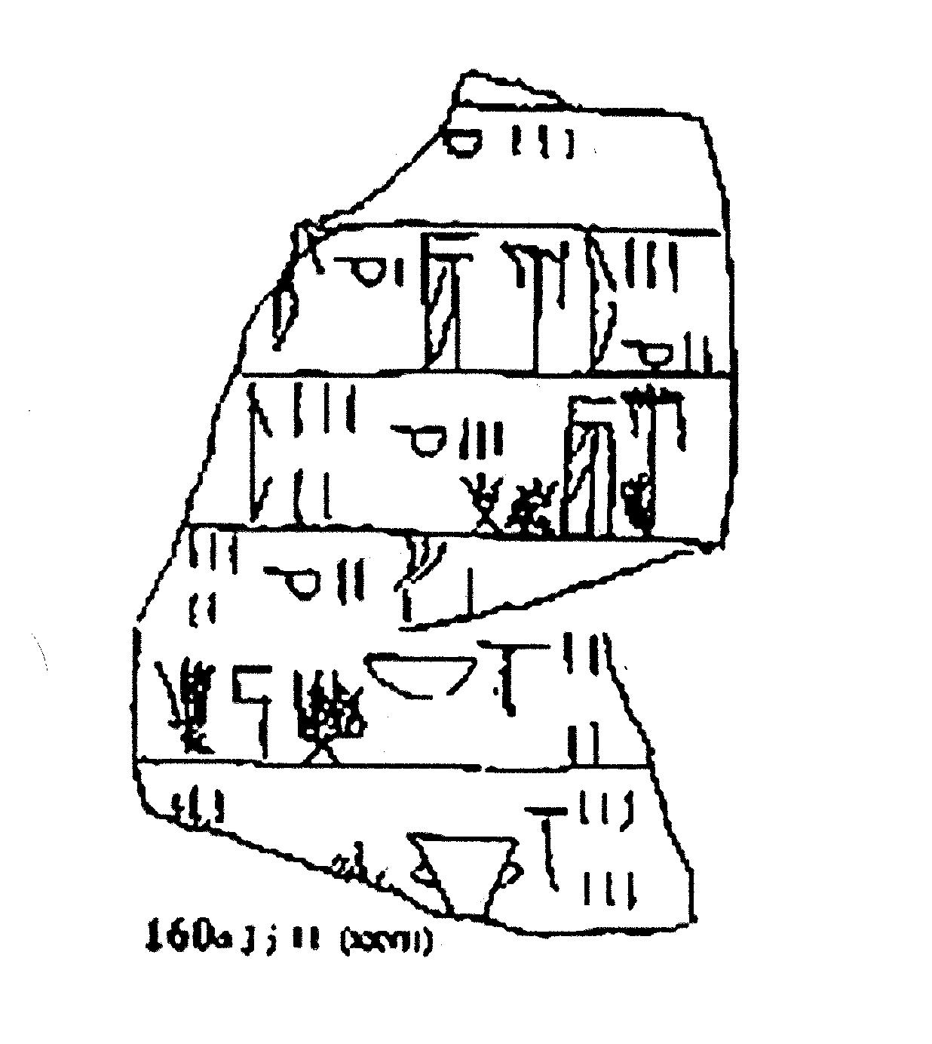

Fig 40

The above Linear B tablet tells us that there are three Supersyllabogram D = D h = di pa = cups of o V = wo no = “wine,” 1 D h = di pa = cup of o V = wo no = wine, 3 Supersyllabogram PE = j H = pe ma = seeds, 2 D h = di pa = cups of o V = wo no = wine, 5 Supersyllabogram PE = j H = pe ma = seeds, 3 D h = di pa = cups of o V = wo no = wine, DEDO ?, 5 D h di pa = cups of o V wo no = wine, 2 units of w N o = e ra wo = olive oil , 4 measures in an e l V = I po no = a kind of pot, 3 measures of cooking o V = wo no = wine in a cooking bowl, and 6 measures of o V wo no = wine in a kylix. It is possible that the seeds were grape seeds. It seems likely that these items may have been in preparation for a feast.

The study of feasting during the Middle and Late Bronze Age where the Kylix cup would have been used provides insights into the nature of the Mycenaean society. It seems that Mycenaean feasting was an expression of the hierarchical, social and political structure of the palaces. Also grave goods discovered demonstrate drinking practices and their importance to the formation of an elite identity.

Conical Cups

The conical cup shape is the most common type and hundreds even thousands have been found, some in houses, indicating a consumable use, such as toasting followed by the smashing of the containers.

The rounded conical cups appear in large numbers during Early Minoan 111 – Middle Minoan1, sometimes not painted but decorated with just a single horizontal band of white paint. Many cups are plain.

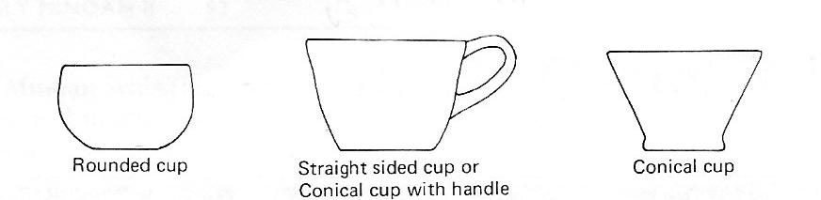

Early Minoan111 Cups

Fig 41 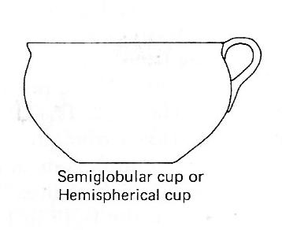

The earliest Middle Minoan examples are decorated with diagonal ridges. By the Middle Minoan 1B, cups are wheel made followed by Middle Minoan11 shape, which is thinly potted and well made. Tall conical cups are known as tumblers, usually without handles and sometimes decorated with a single band of dark or white paint.

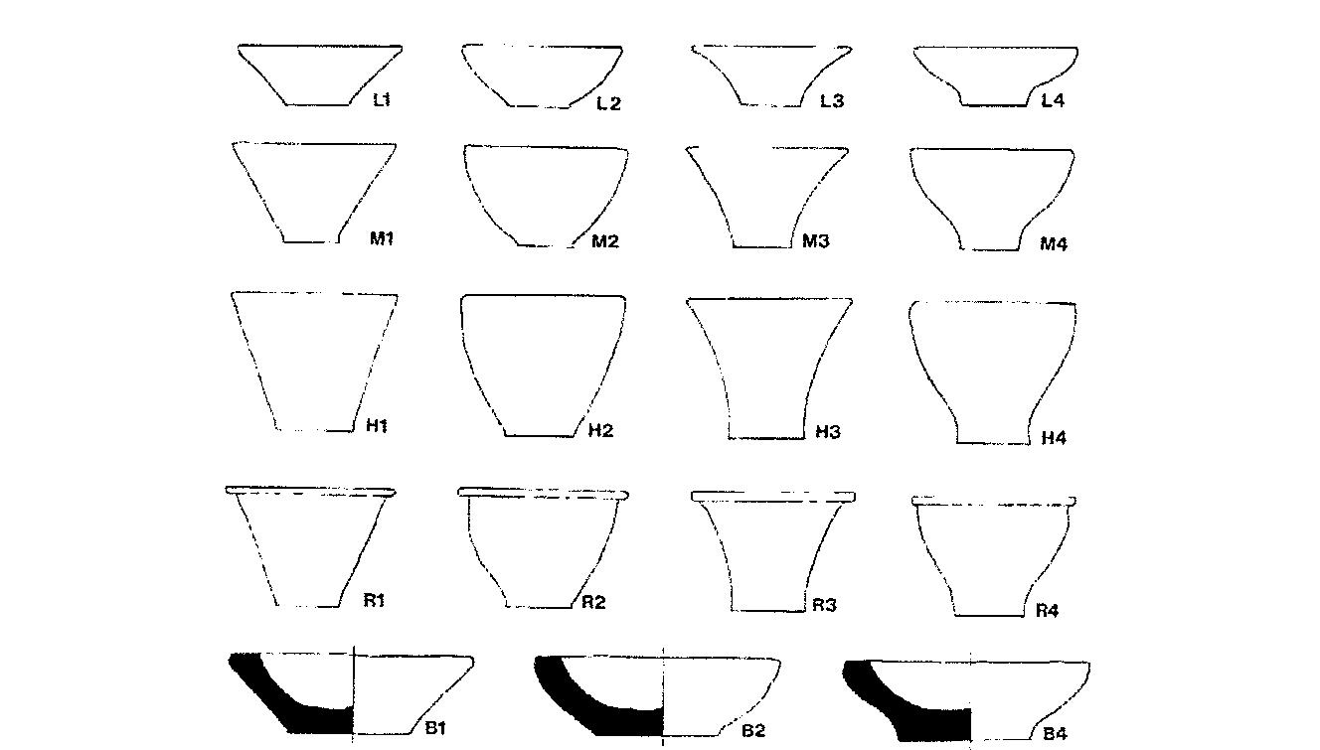

Types of Handleless Cups found in Bronze Age levels at Ayia Irini

Fig 42

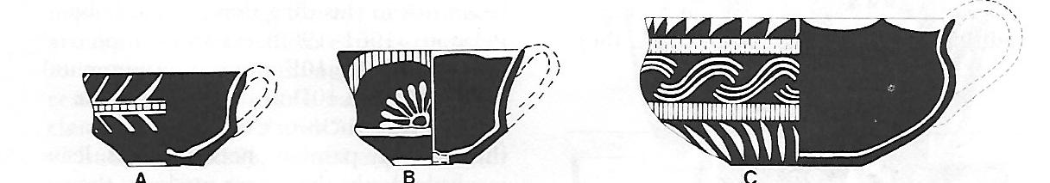

Fig 43

Middle Minoan11 carinated cups A and B semi-globular C

Courtesy Betancourt

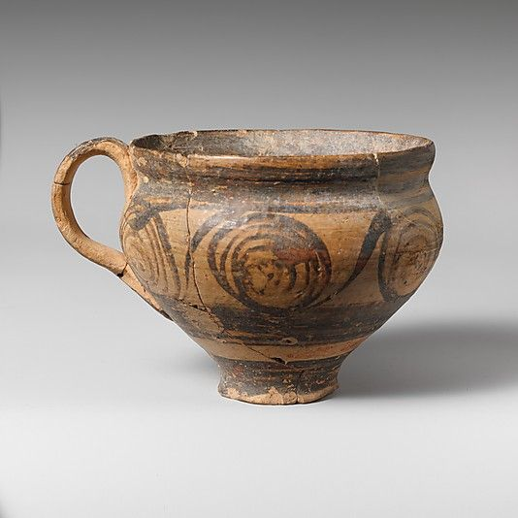

Fig 44 Late Minoan 1 Hemispherical Cup

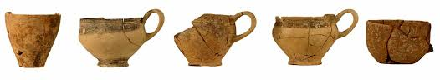

Fig 45 Late Minoan 111 Cups from Gournia.

Conical cups have been found on numerous sites all over Crete, not just settlements large and small, but also burials, peak sanctuaries and caves. They constitute a large percentage of all the pottery found. Conical cups are found not only in Crete they are common at all sites across the Aegean such as Kastri, Ayia Irini on Kea, also Akrotiri on Thera, Milatos and Triada on Rhodes.

While observing the many shapes of cups I can’t help wondering, is it possible the Minoans set the style of the cups of today.

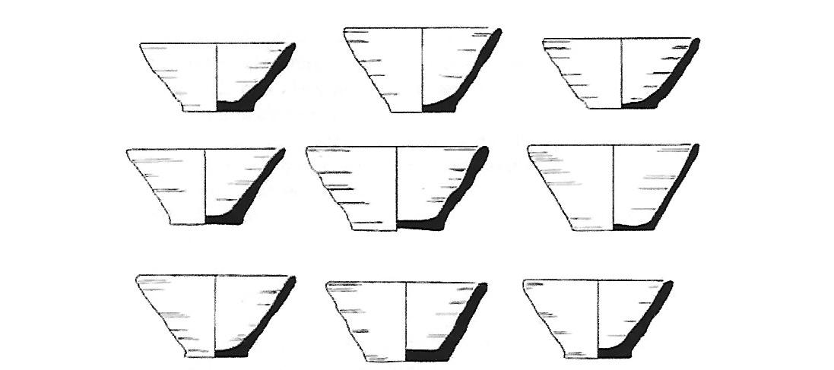

Fig 46 Late Minoan 1A standardized cup from Palaikastro

It would seem that conical cups are an integral part of Minoan civilization both on and off the island of Crete. However, conical cups are not found in all periods of the Bronze Age. They do not appear in the Pre-palatial Bronze Age periods on Crete around 3000 – 1950 BC. Therefore can we concur that they appeared during the First Palatial period (c 1950 – 1700BC), maybe to meet the increased demand associated with the new population centres at sites such as Knossos, Phaistos and Malia.

Between Middle Minoan11B and Middle Minoan111 there seems to be an uninterrupted sequence between styles and among the open shapes, small, fine conical cups, carinated cups, straight- sided cups with concave profiles are no longer made. They are replaced by course conical cups with straight or interned rims, or with outturned rims, and straight- sided cups are sometimes beveled at the bottom of the wall. Semi-globular cups, either large and course, or smaller with thin rims continue to be made.

Of special interest are two decorated cups of the Late Minoan111A1 were found on excavations at Tel-Beth Shemesh Israel in 200l. They were part of a larger assemblage. A scarab bearing the name Amenhotep111 was also found along with the cups, providing further chronological evidence. While it is possible that the Late Minoan111A1 cups came to Tel Beth Shemesh directly from Knossos, another option may have been that they arrived as a gift from the Egyptian Court. The special relations between Amenhotep111l and the Aegean, in the Late Minoan/Late Helladic111A1 period have drawn much attention from other scholars, who visualize an official Egyptian embassy visiting important sites in the region, including Knossos. (Cline 2001,Cline and Stannish 20ll).

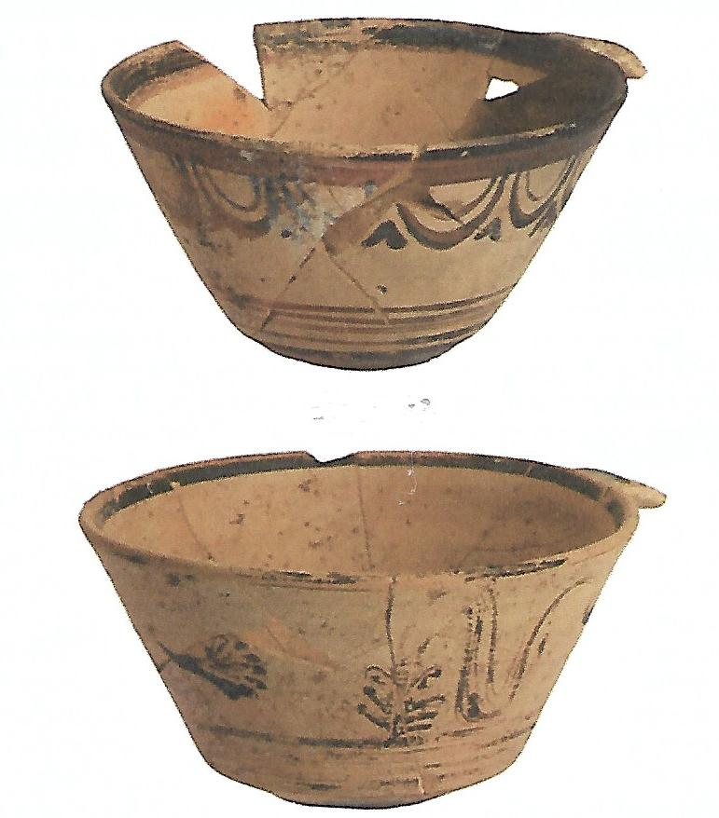

Fig 47 Two decorated cups found at Tel - Beth Shemesh

Courtesy of Eleni Hatzaki, University of Cincinnati

Tortoise-Shell Ripple Ware

Tortoise - Shell ripple ware is the most common lustrous dark – on –light pottery of the Middle Minoan111. It begins in Knossos by Middle Minoan 11 – 111A ( Evans 1921 – 1935: l 592 ) and is still important in Late Minoan 1A. Ornament is usually a reddish brown colour contrasting with the pale Cretan clay. It is thought that the colour is due entirely to Iron oxides (Stos-Fertner, Hedges and Everly 1979; No 11 1977; 1982. Since Middle Minoan shards are also coloured by iron, and since they re-fire to a brown colour if heated in the presence of oxygen (Farnworth and Simmons 1963: 393) , the basic materials were already available for the new technology. Tortoise-Shell Ripple Ware occurs mostly in Middle Minoan111 sites, becoming more popular in Late Minoan 1A. Many shapes include, cups, jars, amphorae, bowls and large storage jars decorated on the small vessels taking up most of the wall with ripples, and on the large shapes it forms horizontal friezes.

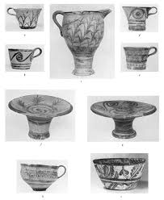

Fig 48 Late Minoan 1A Tortoise - Shell Ripple Ware

Fig 49 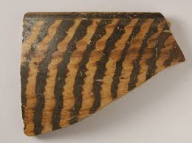

Tortoise-Shell-Ripple shard Middle Minoan111 from Knossos

Some Popular Potters and their Decorations

Kamares Ware

Kamares wares are a distinctive type of Minoan pottery produced in Crete during the Minoan period dating to Middle Minoan1A (ca.2100 BCE) By the Late Minoan 1A period (ca. 1450) or the end of the First Palace Period. The designs are typically executed in white, red and blue on a black field. Typical designs include abstract floral motifs. Surviving examples include ridged cups, small round spouted jars and large storage jars, on which combinations of abstract curvilinear designs and stylized plant and marine motifs are painted in white and tones of red, orange, and yellow on a black background. The Kamares style was often elaborate, with complex patterns on pottery of eggshell thinness. Sets of jugs and cups have been found, and it has been suggested that these may have been used in ritual. However, it is also thought that the exquisite Kamares wares would have been used in the palaces.

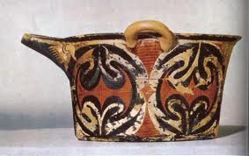

Fig 50 Kamares Ware Jar c1800 – 1700 BC

Agios Onouphrios Ware

The painted parallel – line decoration of the Agios Onouphrios ware was drawn with an iron-red clay slip that would fire red under oxidizing conditions in a clean kiln, but under the reducing conditions of a smoky fire turn darker without much control over colour which could range from red to brown. A dark on – light painted pattern was then applied.

Fig 51 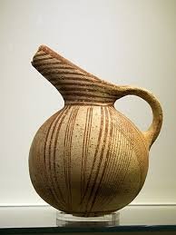

Early Minoan Round Bottom Jug Agios Onouphrios Ware

Vasiliki Ware

Vasilki pottery includes a reddish – brown wash applied early to mimic stone vases. The mottling was produced by uneven firing on the slip – covered pot, with the hottest areas turning dark. There is also a style painted in a creamy white over the reddish – brown wash applied all over the body. The first example of Vasiliki Ware are to be found in Crete during Early Minoan ll A period, but it is in the next period Early Minoan llB that it becomes the dominant form among the fine wares throughout Eastern Crete and Southern Crete.

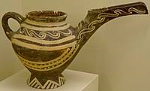

Fig 52 Vasiliki White Style Teapot c 2300 – 2000 BC.

Pyrgos Ware

The major form was the chalice in which a cup combined with a funnel –shaped stand, could be set on a hard surface without spilling. As the Pyrgos site was a rock shelter used as an ossuary, some think it may have been for ceremonial use. This type of pottery was black, grey and brown, burnished and decorated with incised linear designs, possibly in an attempt to imitate wood.

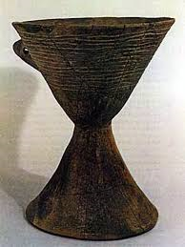

Fig 53 Pyrgos Ware Chalice Early Minoan

Cooking Pots and Cooking Utensils.

Tripod cooking vessels were clearly associated with cooking activities, especially boiling and stewing. However, it is possible they could also have been used for other purposes, such as the washing of textile fibres in hot water, making die- baths also for storage. It is also possible that cook pots were re-used as portable braziers once they were no longer suitable for cooking food .The shapes of cooking pots found on archaeological sites such as Petras vary considerably. The body can be either, a globular or conical profile, a flat base, and everted rim, or plain rim and an open mouth with a spout. The shoulder has two horizontal or, sometimes vertical handles that are round to slightly ovoid in section and less often a third vertical handle is placed opposite the spout.

Due to the many varieties of cooking pot shapes a strict typology is not possible. It seems that previous studies have noted a broad distinction between pots with a narrow mouth and globular profile (Betancourt Type A) and pots with a wide mouth and conical or straighter profile Betancourt Type B) The differentiation is thought to be linked to chronological factors.

Usually the tripod cooking pots have feet which are rounded in section and set high on the vessel; the bases are flat, the mouth generally flared for a collar and there is great variation in sizes; for instance, the largest tripod cooking pot found at Vronda has a height (without legs) of 0.29m and a rim diameter of 0. 27m, while the smallest example is approx 0.12 in height (without legs), with a diameter of 0.12m

At Mochlos it appears that type A pots replace those of type B profile around the end of Late Minoan1A or during Late Minoan1B. The Late Minoan type A pots appear to be an East Cretan phenomenon, whereas Type B cooking pots continue to be used exclusively in Central and West Crete during Late Minoan1B while also occurring in smaller numbers in the East. For a general description of shapes see (Barnard & Brogan 2003, 81).

Cooking trays are also among the vessels used in Minoan cooking. These trays were used for slow cooking at a low temperature rather than for frying.

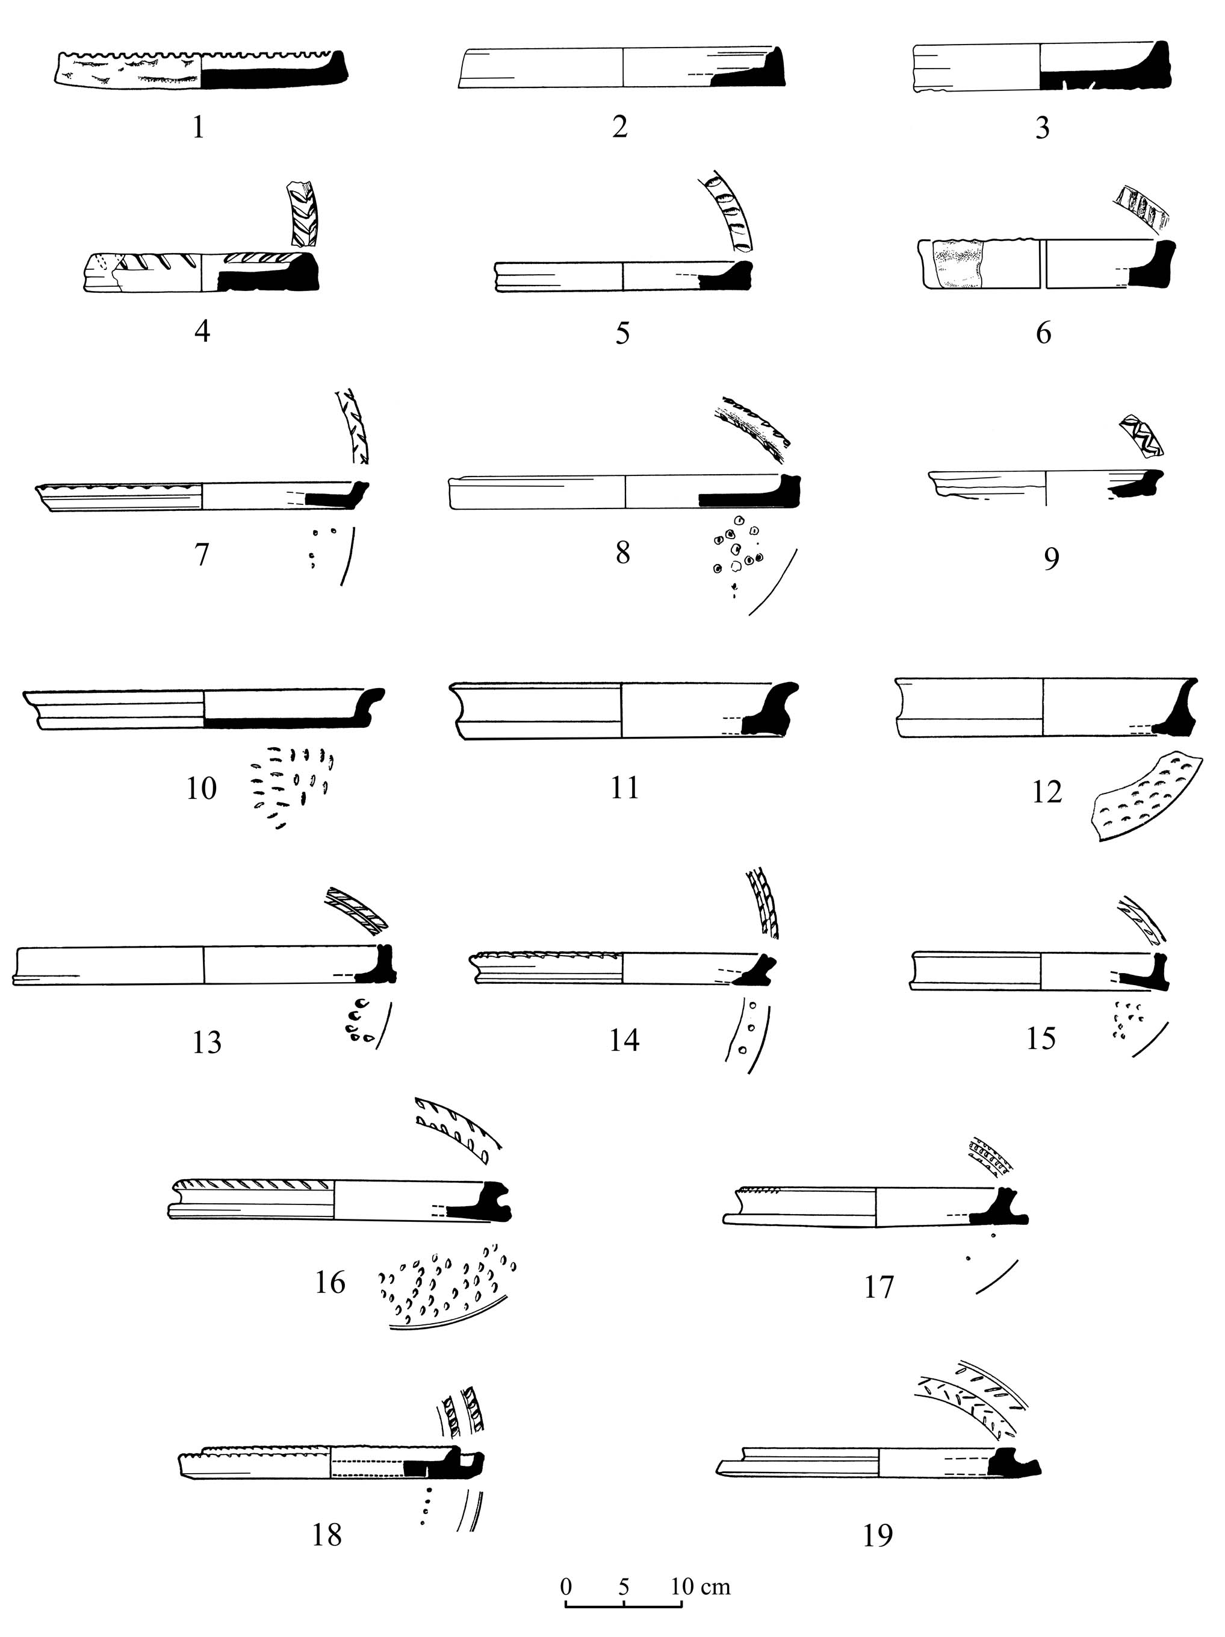

Fig 54

These baking trays in the Second Millenium BCE from the Levant are handmade vessels with short rims and slightly convex or more commonly flat bottomed.

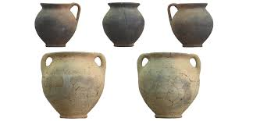

Fig 55 Cooking pots from Mitrou Central Greece

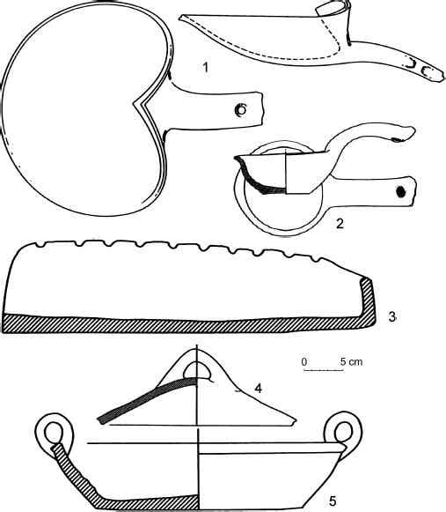

Cooking utensils from Pylos

Fig 56

The Ladle Item 2 has a shallow bowl which is either rounded or slightly angular. It has a flat bottom and the rim seems to be shaped for pouring. The handle is long and thick. The average capacity of the bowl of the ladle was 0.27 litres. It is thought that the ladle was used for stirring-ladling out.

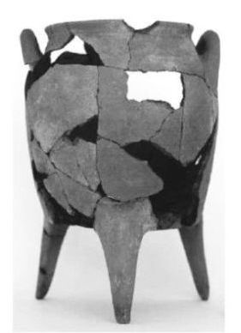

Fig 57 Tripod Cooking Pot from Palaikastro and

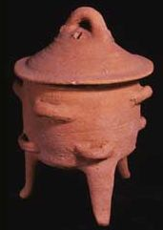 Tripod Cooking Pot from Knossos.

Courtesy the Ashmolean Museum

Fig 58 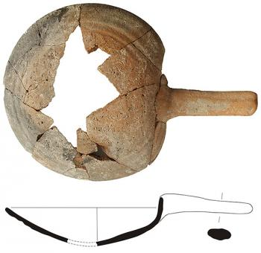

Late Helladic 111A2 Brazier from Mitrou, also found on other settlements, on the Greek mainland.

American Journal of Archaeology Vol l2l,2017 Bartiomiejlis.

Archaeologists excavating at Papadiokambos in 2009, revealed nine rooms on the ground level where a large quantity and vast size range of limpets, top shells and crabs identified by Mylona, suggests the people preparing food in House A l seem to have collected a large part of their sustenance from the shallow coastal waters nearby. Also the remains of olives, grapes, figs and almonds, besides legumes also identified. All would have been available for cooking and eating. (Evi Magaritis, personal comment, 2007).

Three cooking areas, each equipped with one hearth and at least one large vessel with the capacity to hold a substantial meal for multiple individuals. The cooking assemblage from the South porch includes a cooking dish full of limpet shells, a tripod cooking pot, a medium sized piriform jar, a strainer a scoop and several cups. Each of the cooking pots was produced from a different fabric.

A macroscopic fabric analysis by Morrison using a 10x and 30x lens revealed that the cooking dish was made out of an orange – tan sandy fabric with metamorphic inclusions; the tripod cooking pot was made out of an orange fabric, with purple metamorphic inclusions; and the jar out of red fabric with dark red, pink and occasionally blue – grey metamorphic inclusions.

A series of small stone mortars, minimal amounts of goat, pork and beef remains, as well as a substantial heap of discarded burned limpets, partially crushed top shells and crabs were found.

Experimental Archaeology

As a professional trained chef, Jad Alyounis was able to create and prepare a range of foods that might mimic Late Minoan flavours, by using foodstuff which would have been available during this period Late Minoan1B.

In order to test how the occupants of house A l would have used the tripod cooking pot, cooking dish and jar to prepare seafood, similar species of shellfish were collected, such as limpets, patella sp., and top shells, monodonta, turbinata, additional foodstuffs, used either to season the food and as complimentary food dishes, were collected from organic stores and butchers shops.

Using replica cooking dishes, three separate food dishes were prepared. Flat-bread with saffron and coriander seeds, were baked. In one vessel a seafood soup full of top shells, a few limpets and crab was simmered and flavoured with olive oil, leek, garlic, honey, grape syrup and red wine vinegar.

In the second pot, lamb was sautéed with mustard and coriander seed, garlic and leek, and finished off in a Cretan red wine reduction. In the third, various cuts of pork, mainly bacon and pancetta, were sautéed and seasoned with leek, garlic, mustard seed and grape syrup (Moody 2012) The fourth, a cooking dish was turned upside down on supports (to raise it off the coals) and used to bake flat bread on its exterior, domed surface. Previously prepared dishes were re-heated in the tripod cooking pots. The radiated heat created by the small mounds of coals placed between the legs allowed the bodies of the pots to slowly warm.

In one tripod cooking pot cuttlefish cooked with ink was warmed and in the other octopus simmered in beer with leek and garlic. (Moody 2012). For the jars, Alyounis alternated between cooking directly on the coals and elevating the vessel above the coals on supports. In one jar Liver, onions and garlic in water and sweetened with honey and pureed chestnuts was simmered. In the other, lentils with onions, garlic and coriander was prepared and topped off with fresh olive oil (Moody 2012)

Pots and their contents as offerings to the Gods



Fig 59

The above Linear B tablet tells of an offering of olive oil to all the gods – h c s r = pa si te o = to all gods l q ; F c = a pu do si = offering of w N o = e ra wo = “olive oil”.

Ryton – was the Greek name for a vessel perforated at the bottom for the pouring of libations. The aperture was small for the gradual trickling of the liquid. Minoan rhyta have various shapes, such as the Middle Minoan “peg top” form, also an ovoid variety, or typical conical form of rather large dimensions, which first appeared at the beginning of the Late Minoan period in stone and was later copied in clay, sometimes decorated in the Marine Style.

Some clay rhyton recovered from peak sanctuaries are in the form of a bull, sometimes with forepart doubled and taking the place of the hind part of the animal. A unique rhyton in the shape of a long horned beetle has been discovered in the peak sanctuary of Prinias in East Crete.

Another fine example is the Harvester Vase of the Neopalatial period. It is a rhyton of oblong shape, resembling an ostrich egg with a unique scene depicting a procession of men walking in groups and carrying harvesting tools on their shoulders.

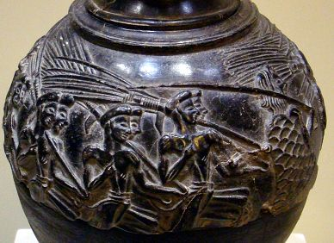

Fig 60 The Harvester Rhyton

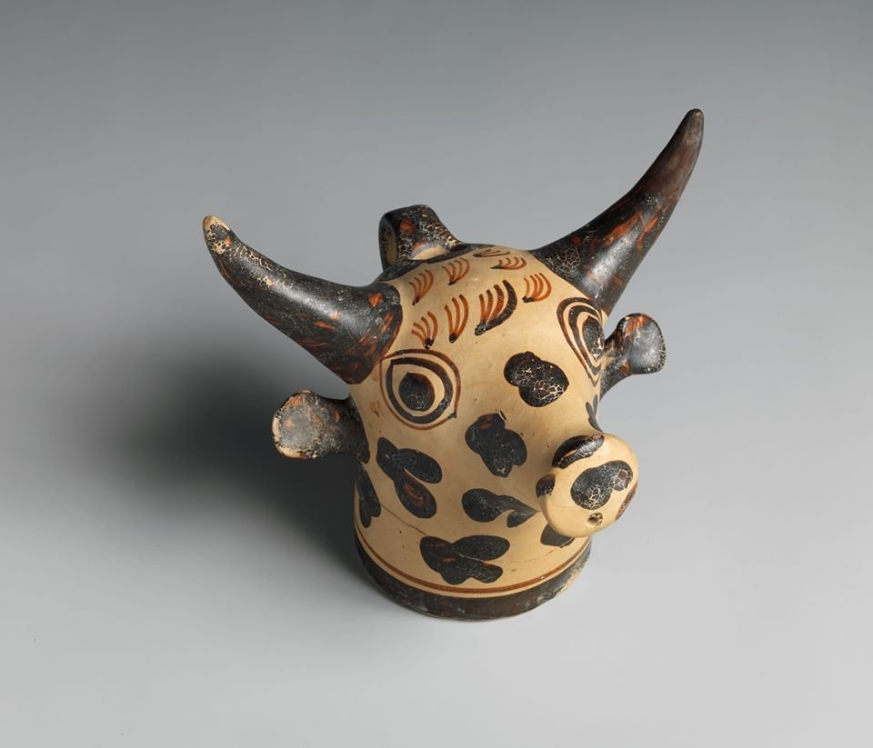

Minoan Rhyton in the shape of a bulls head c 1450 – 1400 BC

Fig 61 Courtesy of the Metropolitan Museum.

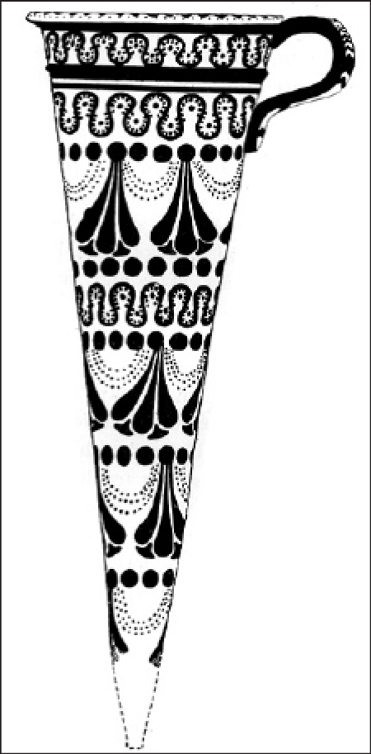

Fig 62 Conical Rhyton decorated with the “Crocus and Festoon” LM1B

From Palaikastro (Betancourt 1985)

The earliest representation of a crocus flower can be seen on an early Kamares cup from Knossos and dating to Middle Minoan1A – 1B. Trifoliates become more popular as a decorative motif in Middle Minoan1B-11, but it is the prominently protruding stigmas of the crocus, which allow for its specific identification. In Late Minoan1B, crocus iconography reached its peak, its artistic height visible in the detailed “crocus and festoon” motif found on *rhta* and vases in Crete and Cycladic islands By Late Minoan111 the crocus flower became less popular as a decorative motif but continued to be represented iconographically in the ideograms of Linear B, the written language of the period.

Incense Burners

A specialized shape, the incense burner is first known from Late Minoan 111A; its origins are unknown. The shape consists of two separate pieces, a cup and a cover. The cup normally has a flat base and vertical sides, with a single handle for lifting. Its matching cover with a cut out portion to accommodate the cup’s handle is made with a cylindrical lower part and a higher pierced top. The normal context is tombs and shrines. The specialized cult vessel long a part of Minoan ceramic tradition, develop new ideas and several types exist: such as effigy figures; vessels for incense or aromatics; elaborate stands; and other special shapes.

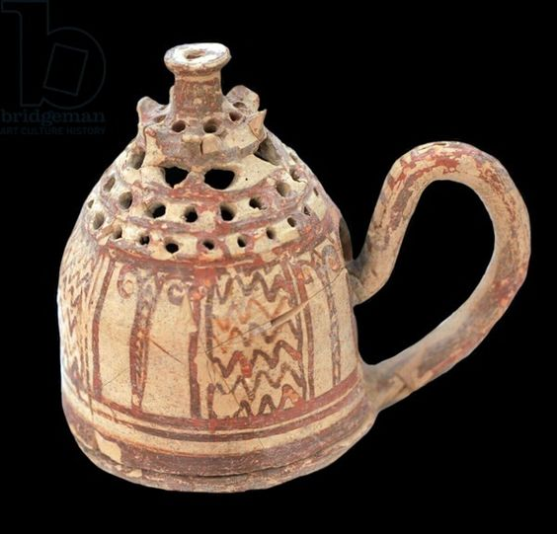

Fig 63 Late Minoan Incense Burner from Ierapetra

At the end of Late Minoan1B Crete becomes more dependent on the Mycenaean ideas, whereby we see that the Mycenaean potters adapted styles from the well established Minoan pottery tradition, especially in areas close to Crete. An abundance of Mycenaean pottery has been found in Italy and Sicily, suggesting that they were in contact and trading with the Mycenaeans.

In Late Helladic 1-11A pottery is distinguished by the use of a more lustrous paint than their predecessors, whereas in the Middle Helladic period matt paints were used on Middle Helladic shapes.

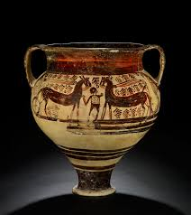

Fig 64 Late Helladic111 A2 Krater Lustrous Painted.

There is some question with regard to how much of the pottery of Early Mycenaean age, relies on Minoan pottery for both their shapes and patterns. For at least the first half of the seventeenth century B C there is only a small amount of all pottery produced that is in the Minoan style.

Pottery in the Late Helladic l (c1675-1650 – 1600-1550 varies somewhat in style from one area to another. Due to the influence of Minoan Crete, the further south the site, the more the pottery is of Minoan styles. Some of the matt painted wares from the Middle Helladic period carry on into the Late Helladic period.

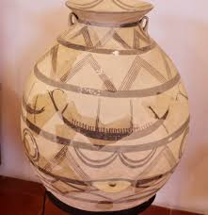

Fig 65 Middle Helladic Matt Painted Jar.

The majority of large closed vessels that have any painted decorations, are matt and are generally decorated in two styles of matt paints known as, *Aeginetan Dichrome* and *Mainland Polychrome*. Some of the popular shapes of this period were the Vapheio Cup, semi globular cup, alabastron and piriform jar.

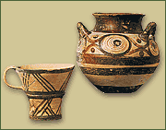

Fig 66 Late helladic Vapheio Cup and Alabastron from Mycenae

In the Late Helladic11A (c.1600-1550 – 1490 – 1470 BC) there seems to be an increase in uniformity in the Peloponnese in both painting and shape. However, Central Greece is still recognised as Helladic pottery, showing little Minoan influence. By this time the matt painted pottery is less common.

During Late Helladic111A1 (1435 - 1405 - 1390 -1370 BC) many changes occur. The transformation from Goblet to Kylix whereby the goblet lengthens its stem and in this period, the stirrup jar becomes a popular style.

In Late Helladic 111A2 (c1390 – 1370 – 1320 – 1300 BC), The stirrup jar, piriform jar and alabastron are mostly found in tombs. The Kylix becomes the dominent shape of pottery found in settlements during this period while the deep bowl becomes the most popular decorated shape during the Late Helladic111B (C 1320 - 1300 – ll90 BC),although, for unpainted wares the Kylix is still the most produced. During the period Late Helladic111B1 there were two sub – phases, characterized by the presence of both painted deep bowls and kylikes and in the Late Helladic111B2 there is an absence of decorated Kylix and deep bowl styles develop in rosette form.

Conclusion

It is unknown how long each sub-phase lasted, however, by the end of the Late Helladic111B2 the palaces of Mycenae and Tyrins and the citadel at Midea had all been destroyed. The palace of Pylos was also destroyed at some point during this time, but it is impossible to tell when in relation to the others the destruction took place.

It seems that the ceramic shapes and decorations discovered during this final period, show that the production of pottery was reduced to little more than a household industry, suggesting that this must have been a time of decline in Greece. Today, however, the reproductions of these exquisite forms and decorations of the Minoan and Myceaean pottery, still holds its popularity throughout the world as it did in ancient times.